sets

Section 1
- Definition: A set is a well-defined collection of objects.
There are two methods of representing a set
- Roaster or tabular form
e.g. natural numbers less than 5 = {1, 2, 3, 4}
(ii) Set builder form
e.g. : Vowels in English alphabet
= {x : x is a vowel in the English alphabet }
Section 2
- Types of sets

- Empty set or Null set or void set: A set which does not contain any element is called null set.
(ii) Finite set: A set which consists of a definite number of elements is called Finite set.
(iii) Infinite set: A set which consists of a indefinite number of elements is called infinite set.
(iv) Singleton set: A set having exactly one element is called singleton set.

- Subset :– A set A is said to be a subset of set B if a ∈A ⇒ a ∈B, ∀ a ∈Α
Note: If A ⊂ B and A ≠ B , then A is called a proper subset of B and B is called superset of A.

- Equal sets :– Two sets A and B are equal if they have exactly the same elements i.e A = B if A ⊂ Β and B ⊂ A

- Power set : The collection of all subsets of a set A is called power set of A, denoted by P(A) i.e. P(A) = { B : B ⊂ A }

- If A is a set with n(A) = m then n [P(A)] = 2^{m}.
- Equivalent sets : Two finite sets A and B are equivalent, if their cardinal numbers are same i.e., n(A) = n(B).

- Types of Intervals
Open Interval (a, b) = { x ∈ R : a < x < b }
Closed Interval [a, b] = { x ∈ R : a ≤ x ≤ b }
Semi open or Semi closed Interval,

(a,b] = { x ∈ R : a < x ≤ b}
[a,b) = { x ∈ R : a ≤ x < b}
Section 3
- Universal set
This is a basic set; in a particular context whose elements and subsets are relevant to that particular context. For example, for the set of vowels in
English alphabet, the universal set can be the set of all alphabets in English. Universal set is denoted by U
- Venn diagrams
Venn Diagrams are the diagrams which represent the relationship between sets. For example, the set of natural numbers is a subset of set of whole numbers which is a subset of integers. We can represent this relationship through Venn diagram in the following way.
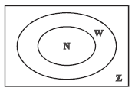
- Operations on sets
- Union of two sets A and B is,
A ∪ B = { x : x ∈ A or x ∈ B }
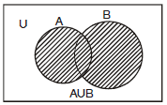
Properties of the operation of union.
(i) A ∪ B = B ∪ A (ii) (A ∪ B) ∪ C = A ∪ (B ∪ C)
(iii) A ∪ φ = A (iv) A ∪ A = A (v) U ∪ A = U

- Intersection of two sets A and B is,
A ∩ B = { x : x ∈ A and x ∈ B}
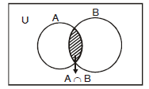
Properties of the operation of intersection
(i) A ∩ B = B ∩ A (ii) (A ∩ B) ∩ C = A ∩ (B ∩ C)
(iii) φ ∩ A = φ ; U ∩ A = A (iv) A ∩ A = A
(v) A ∩ (B ∪ C) = (A ∩ B) ∪ (A ∩ C)
(vi) A ∪ (B ∩ C) = (A ∪ B) ∩ (A ∪ C)
- Disjoint sets : Two sets A and B are said to be disjoint if A ∩ B = φ
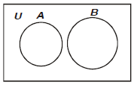
- Difference of sets A and B is,
A – B = { x : x ∈ A and x ∉ B}
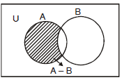
- Difference of sets B and A is,
B – A = { x : x ∈ B and x ∉ A }
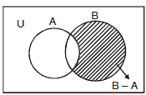
- Complement of a set A, denoted by A' or A^{c} is
A' = A^{c} = U – A = { x : x ∈ U and x ∉ A}
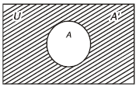
Properties of complement sets :
1. Complement laws
(i) A ∪ A' = U (ii) A ∩ A' = φ (iii) (A')' = A

2. De Morgan's Laws
(i) (A ∪ B)' = A' ∩ B' (ii) (A ∩ B)' = A' ∪ B'
3. φ' =  and  ' = φ
Section 4
Laws of Algebra of sets.
(i) A ∪ φ = A
(ii) A ∩ φ = φ
 A – B = A ∩ B'

 Commutative Laws :–
(i) A ∪ B = B ∪ A (ii) A ∩ B = B ∩ A

 Associative Laws :–
(i) (A ∪ B)∪ C = A ∪ (B ∪ C) (ii) (A ∩ B) ∩ C = A ∩ (B ∩ C)

 Distributive Laws :–
(i) A ∩ (B ∪ C) = (A ∩ B) ∪ (A ∩ C)
(ii) A ∪ (B ∩ C) = (A ∪ B) ∩ (A ∪ C)

 If A ⊂ B, then A ∩ B = A and A ∪ B = B

 When A and B are disjoint n(A ∪ B) = n(A) + n(B)

 When A and B are not disjoint
n(A ∪ B) = n(A) + n(B) – n(A ∩ B)

 n(A ∪ B ∪ C) = n(A) + n(B) + n(C) – n(A ∩ B) – n(B ∩ C) – n(A ∩ C) + n(A ∩ B ∩ C)
Some important symbols
N : the set of all natural numbers
Z : the set of all integers
Q : the set of all rational numbers
R : the set of real numbers
Z⁺ : the set of positive integers
Q⁺ : the set of positive rational numbers, and
R⁺ : the set of positive real numbers.

Worksheet CSBE
Q1 Write the set,in the set builder form
Ans:
Q2 Write the following sets in the roaster form.
(i) A = {x : x is a positive integer less than 10 and 2^{x} – 1 is an odd number}
(ii) C = {x : x² + 7x – 8 = 0, x ∈ R}
Ans: i) {1, 2, 3, 4, 5, 6, 7, 8, 9}.
ii) {– 8, 1}
Q3 From 50 students taking examinations in Mathematics, Physics and Chemistry, each of the student has passed in at least one of the subject, 37 passed Mathematics, 24 Physics and 43 Chemistry. At most 19 passed Mathematics and Physics, at most 29 Mathematics and Chemistry and at most 20 Physics and Chemistry. What is the largest possible number that could have passed all three examination?
Ans: 14

Q4 Each set Xr contains 5 elements and each set Yr contains 2 elements and . If each element of S belong to exactly 10 of the Xr’s and to exactly 4 of the Yr’s, then n is equal to.
Ans: 20

Q5 In a town of 10,000 families, it was found that 40% families buy newspaper A, 20% families buy newspaper B and 10% families buy newspaper C. 5% families
buy A and B, 3% buy B and C and 4% buy A and C. If 2% families buy all the three
papers. Find the no. of families which buy
- A only (ii) B only (iii) none of A, B, and C.
Ans: i)3300
ii)1400
iii)4000

Q6 Two finite sets have m and n elements. The total no. of subsets of the first set is
56 more than the total no. of subsets of second set. Find the value of m and n.
Ans: 6
Q7 A college awarded 38 medals in football, 15 in basketball and 20 in cricket. If these medals went to a total of 58 men and only three men got medals in all the three sports, how many received medals in exactly two of the three sports ?
Ans: 9
Q8 Let A and B be sets. If A ∩ X = B ∩ X = φ and A ∪ X = B ∪ X for some set X, show that A = B.
Q9 List all the subsets of the set {-1,0,1}
Ans:
Q10 Let U = {1, 2, 3, 4, 5, 6} A = {2, 3} and B = {3, 4, 5} Find A′∩B′, A∪B and hence show that (A∪B)′ = A′∩B′ .
Ans: (A∪B)′ = A′∩B′ ={1, 6}

A relation is a set of inputs and outputs, often written as ordered pairs (input, output). We can also represent a relation as a mapping diagram or a graph. For example, the relation can be represented as:
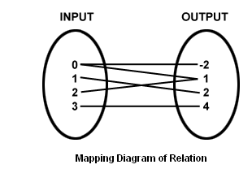
Lines connect the inputs with their outputs. The relation can also be represented as:
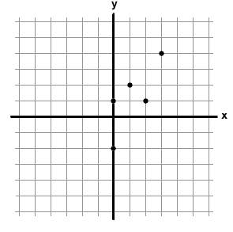

Thus the relation in a set A is a subset of A × A. Thus, the empty set φ and A × A are twoextreme relations.

Types of Relations
1]Empty relation: A relation R in a set A is called empty relation, if no element of A is
related to any element of A, i.e., R = φ ∈ A × A.
2] Universal relation: A relation R in a set A is called universal relation, if each element of A is related to every element of A, i.e., R = A × A.

3] Identity relation: A relation R in a set A is called identity relation, if
R={(a,b):a∈A,b∈A and a=b}

4] Reflexive relation: A relation R is said to be reflexive over a set A if (a,a) € R for every a € R.

Examples:If A is the set of all males in a family, then the relation “is brother of” is not reflexive over A. Because any person from the set A cannot be brother of himself.

The relation R = {(1,1)(2,2)(3,3)} is reflexive over the set A = {1,2,3}.

5] Symmetric relation: A relation R is said to be symmetric if (a,b) ∈ R => (b,a) ∈ R
Examles:If A is the set of all males in a family, then the relation “is brother of” is symmetric over A.Because if a is brother of b then b is brother of a.
If A is the set of mothers and B is the set of children in a family then a relation R on AxB is not symmetric because if a is mother of b then b cannot be mother of a.
6] Transitive relation: A relation R is said to be symmetric if (a,b) ∈ R, (b,c) ∈ R => (a,c) ∈R.
Examles: If A is the set of all males in a family, then the relation “is brother of” is transitive over A.Because if a is brother of b and b is brother of c then a is brother of c.
The relation R = {(1,1)(2,2)(3,3)(1,2)(2,3)} is not transitive over the set A = {1,2,3} because thought (1,2), (2,3) ∈R , (1,3) is not in R.

7] Equivalence relation: A relation R in a set A is said to be an equivalence relation if R is
reflexive, symmetric and transitive.
 Exercise1.1
Q1 Let A be the set of all students of a boys school. Show that the relation R in A given by R = {(a, b) : a is sister of b} is the empty relation and R/ = {(a, b) : the difference between heights of a and b is less than 3 meters} is the universal relation [NCERT]
Q2 Let T be the set of all triangles in a plane with R a relation in T given by
R = {(T₁, T₂) : T1 is congruent to T₂}. Show that R is an equivalence relation.
[NCERT]
Q3 Let L be the set of all lines in a plane and R be the relation in L defined as R = {(L1, L2) : L1 is perpendicular to L2}. Show that R is symmetric but neither reflexive nor transitive. [NCERT]
Q4 Show that the relation R in the set {1, 2, 3} given by R = {(1, 1), (2, 2),(3, 3), (1, 2), (2, 3)} is reflexive but neither symmetric nor transitive. [NCERT]
Q5 Show that the relation R in the set Z of integers given by R = {(a, b) : 2 divides a – b}is an equivalence relation. [NCERT]
Q6 Let A = {3, 5} and B = {7, 11}. Let R = {(a, b): a ∈ A, b ∈ B, a – b is odd}.Show that R is an empty relation from A into B
Q2 Let A = {3, 5}, B = {7, 11}. Let R = {(a, b): a ∈ A, b ∈B, a – b is even}. Show that R is an universal relation from A into B
Q3 Let A = {1, 2, 3} and R = {(a, b): a, b ∈ A, a divides b and b divides a}. Show that R is an identity relation on A.
Q4 Let R be a relation from N into N defined by R = {(a, b): a, b ∈ N and a = }. Are the following true?
- (a, a) ∈ R, for all a ∈ N
- (a, b) ∈ R implies (b, a) ∈ R
- (a, b) ∈ R, (b, c) ∈ R implies (a, c) ∈ R?
Justify you answer in each case.
Q5 Prove that the relation R defined on the set N of natural numbers by xRy i.e., by R = {(x, y): x, y ∈ N and is not symmetric but it is reflexive.
Q6 Let N be the set of natural numbers and relation R on N be defined as xRyx divides y i.e., as R = {(x, y): x, y ∈ N and x divides y}. Examine whether R is reflexive, Symmetric, or transitive.
Q7 Let S be any non empty set and P(S) be its power set. We define a relation R on P(S) by ARB to mean AB; i.e., R= {(A, B): A B}. Examine whether R is (i) reflexive (ii) Symmetric (iii) transitive.
Q8 Prove that a relation R on a set A is (i) reflexive = {(x, x): x ∈ A} (ii) symmetric .
Q9 Give examples of relation which are
- Neither reflexive nor symmetric nor transitive.
- Symmetric and reflexive but not transitive.
- Reflexive and transitive but not symmetric

Past year CBSE Questions

Q1 Let T be the set of all triangles in a plane with R as relation in T given by ,Show that R is an equivalence relation.
[CBSE AI-2008]
Q2 Prove that the relation R on the set A={1,2,3,4,5} given by is an equivalence relation.
[CBSE Delhi-2009]
Q3 Let Z be the set of all integers and R be the relation on Z defined as R = {(a, b) : a,b∈Z and a – b is divisible by 5.}.Prove that R is an equivalence relation.
[CBSE Delhi-2010]
Q4 Show that the relation S in the set given by is an equivalence relation.Find the set of all elements related to 1.
[CBSE AI- 2010]
Q5 State the reason for the relation R ,in the set {1,2,3} given by R={(1,2),(2,1)},not a transitive.
[CBSE AI- 2011]
Q6 Show that the relation R defined by : (a,b)R(c,d)⇒a+d=b+c on the set N is an equivalence relation
[HOTS]

Past year AIEEE/IIT Questions

Q1 Let R={(1,3),(4,2),(2,4),(2,3),(3,1)} be a relation on the set A={1,2,3,4}.The relation R is
[AIEEE-2004]
a) not symmetric
b) transitive
c) a function
d) reflexive

Q2 Let R = {(3, 3), (6, 6), (9, 9), (12, 12), (6, 12), (3, 9), (3, 12), (3, 6)} be a relation on the set A = {3, 6, 9, 12} be a relation on the set A = {3, 6, 9, 12}. The relation is
[AIEEE-2005]
(a) reflexive and transitive only
(b) reflexive only
(c) an equivalence relation
(d) reflexive and symmetric only

Q3 Let W denote the words in English dictionary.Define the relation R by Then R is
[AIEEE-2006]

- not reflexive, symmetric and transitive
- reflexive, symmetric and not transitive
- reflexive, symmetric and transitive
- reflexive, not symmetric and transitive
Q4 Let R be the real line .Consider the following subsets of the plane RXR:
Which of the following statement is true?
[AIEEE-2008]
- T is an equivalence relation on R but S is not.
- Neither T nor S is an equivalence relation on R
- Both S and T are is an equivalence relation on R
- S is is an equivalence relation on R but T is not

Q1: Let R be a relation defined on the set by . Then the number of elements in R is
- 6 (b) 15
(c) 12 (d) 18
Q2: Consider two Sets and. Then the number of onto functions is equal to :
- 32 (b) 81
(c) 79 (d) 62
Q3: Let . Let R be a relation on A defined by if and only if is a multiple of 3. Given below are two statements
Statement I :
Statement II : R is an equivalence relation
In the light of the above statements, choose the correct answer from the options given below :
- Statement I is correct but Statement II is incorrect.
- Both Statement I and Statement II are correct.
- Both Statement I and Statement II are incorrect.
- Statement I is incorrect but Statement II is correct.
Q4: Let . Let R be a relation on A defined by if and only if Let be the number of elements in R. Let m and n be the minimum number of elements required to be added in R to make it reflexive and symmetric relations respectively. Then is equal to :
- 34 (b) 32
(c) 33 (d) 35
Q5: The number of elements in the relation
- 86 (b) 67
(c) 89 (d) 77
Q6: Let the relation R on the set be given by Then the minimum number of elements required to be added in R, in order to make the relation symmetric , is equal to
- 4 (b) 3
(c) 1 (d) 2
Q7: Let and . Then
- (b)
(c) (d)
Q8: Let . Let R be the relation on A defined by if and only if Let be the number of elements in R, and m be the minimum number of elements required to be added in R to make it a symmetric relation. Then is equal to :
- 21 (b) 25
(c) 23 (d) 27
Q9: The number of relations, defined on the set {a,b,c,d}, which are both reflexive and symmetric, is equal to :
- 16 (b) 64
(c) 256 (d) 1024

Q1: Let A = {0, 1, 2, 3, 4, 5}. Let R be a relation on A defined by (x, y) ∈ R if and only if max{x, y} ∈ {3, 4}. Then among the statements
(S₁): The number of elements in R is 18, and
(S₂): The relation R is symmetric but neither reflexive nor transitive

- both are false (b) only (S₁) is true
(c) only (S₂) is true (d) both are true
Q2: Let and
Then
- (b)
(c) neither nor (d)
Q3: Let and R be a relation on A defined by if and only if . Let be the number of elements in R . Let m and n be the minimum number of elements required to be added in R to make it reflexive and symmetric relations, respectively. Then is equal to:
- 17 (b) 18
(c) 15 (d) 16
Q4: Consider the sets , ,and . The total number of one-one functions from the set D to the set C is :
- 15120 (b) 18290
(c) 17160 (d) 19320
Q5: Let . Let R be a relation on defined by if and only if . Let be the number of elements in . Let and be the minimum number of elements required to be added in R to make it reflexive and symmetric relations, respectively. Then is equal to
- 11 (b) 12
(c) 14 (d) 13
Q6: Let . Let R be a relation on A defined by if and only if Let be the number of elements in R and m be the minimum number of elements required to be added in R to make it a reflexive relation. Then is equal to:
(a) 18 (b) 20
(c) 17 (d) 19
Q7: Let and R be a relation on such that Let ,,,……..,be a sequence of elements of R such that the second entry of an ordered pair is equal to the first entry of the next ordered pair. Then the largest integer , for which such a sequence exists, is equal to
- 6 (b) 8
(c) 7 (d) 5
Q8: Let be the set of all functions and R be a relation on A such that . Then R is :
- Symmetric and transitive but not reflexive
- Symmetric but neither reflexive nor transitive
- Transitive but neither reflexive nor symmetric
- Reflexive but neither symmetric nor transitive
Q9: Let Define a relation R from S to by: Then, the sum of all the elements in the range of R is equal to:
- (b)
(c) (d)
Q10: Define a relation R on the interval by if and only if. Then R is:
- Both reflexive and symmetric but not transitive.
- Both reflexive and transitive but not symmetric.
- Reflexive but neither symmetric not transitive
- An equivalence relation
Q11. The relation is:
- Reflexive and transitive but not symmetric
- Reflexive and symmetric but not transitive.
- An equivalence relation.
- Symmetric and transitive but not reflexive.
Q12: Let and Then is equal to
- 4 (b) 8
(c) 6 (d) 2
13: Let . Define a relation R on X as:
Statement I: R is an equivalence relation.
Statement II: For some , the set represents a line parallel to .
In the light of above statements,choose the correct answer from the options given below:
- Both Statement I and Statement II are true.
- Statement I is true but Statement II is false.
- Both Statement I and Statement II are false.
- Statement I is false but Statement II is true.
14. Let and If ,then is :
(a) 18 (b) 24
(c) 15 (d) 12
15. Let be a relation defined on the set . Then the minimum number of elements, needed to be added in R so that R becomes an equivalence relation, is:
(a) 9 (b) 8
(c) 7 (d) 10
16. Let and . Then is equal to:
(a) 29 (b) 31
(c) 37 (d) 36
17. The number of non-empty equivalence relations on the set {1,2,3} is:
(a) 7 (b) 4
(c) 5 (d) 6

Q1: Let and . Let R be a relation on defined by if and only if is an even integer. Then the relation R is
- Reflexive but not symmetric.
- An equivalence relation.
- Reflexive and symmetric but not transitive.
- Transitive but not symmetric.
Q2: Let Let R be a relation on A defined by if and only if . Let m be the number of elements in R and n be the minimum number of elements from that are required to be added to R to make it a symmetric relation. Then m+n is equal to:
- 23 (b) 26
(c) 25 (d) 24
Q3: Let n is neither a multiple of 3 nor a multiple of 4} . Then the number of elements in A is
- 300 (b) 310
(c) 290 (d) 280
Q4: Let the relations and on the set be given by and If M and N be the minimum number of elements required to be added in and , respectively , in order to make the relations symmetric, then M+N equals
- 16 (b) 12
(c) 8 (d) 10
Q5: Let a relation R on be defined as :if and only ifor . Consider the two statements:
- R is reflexive but not symmetric.
- R is transitive.
Then which one of the following is true?
(a) Only (II) is correct. (b) Both (I) and (II) are correct.
(c) Neither (I) nor (II) is correct. (d) Only (I) is correct.
Q6: Consider the relations and defined as for all and for all . Then
- and both are equivalence relations.
- Only is an equivalence relation.
- Only is an equivalence relation.
- Neither nor is an equivalence relation.
Q7: If R is the smallest equivalence relation on the set such that , then the number of elements in R is
- 15 (b) 10
(c) 12 (d) 8
Q8: Let R be a relation on defined by if and only if is divisible by 5. Then R is
- Reflexive and transitive but not symmetric.
- Reflexive and symmetric but not transitive.
- Reflexive but neither symmetric nor transitive.
- Reflexive, symmetric and transitive.
Q9: Let A and B be two finite sets with m and n elements respectively. The total number of subsets of the set A is 56 more than the total number of subsets of B. Then the distance of the point from the point Q(-2,-3) is:
- 8 (b) 10
(c) 4 (d) 6
Q10: Let . Suppose M is the set of all the subsets of S, then the relation is:
- Symmetric only. (b) Reflexive only.
(c) Symmetric and Reflexive only. (d) Symmetric and Transitive only.

Q1: Let and Let be a relation defined on such that . Then the number of elements in the set R is:
- 180 (b) 26
(c) 52 (d) 160
Q2: An organization awarded 48 medals in event 'A', 25 in event 'B' and 18 in event 'C'. If these medals went to total 60 men and only five men got medals in all the three events, then, how many received medals in exactly two of three events?
- 10 (b) 15
(c) 21 (d) 9
Q3: Let and . Then the number of elements in the relation divides and divides is:
- 18 (b) 24
(c) 36 (d) 12
Q4: Let Then the relation is:
- Reflexive but neither symmetric nor transitive.
- Transitive but neither symmetric nor reflexive.
- Symmetric but neither reflexive nor transitive.
- An equivalence relation.
Q5: Let denote the power set of Define the relations and on as if and if ,. Then :
- only is an equivalence relation
- both and are not equivalence relations
- both and are equivalence relations
- only is an equivalence relation
Q6: Let R be a relation on , given by is an irrational number }. Then R is
- an equivalence relation
- reflexive and symmetric but not trasitive
- reflexive and transitive but not symmetric
- reflexive but neither symmetric nor transitive
Q7: Among the relations
and
- S is transitive but T is not
- Both S and T are symmetric
- Neither S nor T is transitive
- T is symmetric but S is not
Q8: Let R be a relation on defined by if and only if Then R is
- Symmetric and transitive but not reflexive
- Reflexive and symmetric but not transitive
- Trasitive but neither reflexive nor symmetric
- Symmetric but neither reflexive nor transitive
Q9: The minimum number of elements that must be added to the relation on the set so that it becomes symmetric and transitive is :
- 7 (b) 3
(c) 4 (d) 5
Q10: Let R be a relation defined on as if is a multiple of . Then R is
- An equivalence relation (b) non-reflexive
(c) Symmetric but non transitive (d) transitive but not symmetric
Q11: The relation is:
- Reflexive but not symmetric (b) Transitive but not reflexive
(c) Symmetric but not transitive (d) neither symmetric nor transitive

Q1: Let R be a relation from the set to itself such that where are prime numbers}. Then, the number of elements in R is :
- 600 (b) 660
(c) 540 (d) 720
Q2: For , consider a relation R on given by is a multiple of 7}. The relation R is an equivalence relation if and only if :
- (b) is a multiple of 4
(c) 4 is the remainder when is divided by 10
(d) 4 is the remainder when is divided by 7
Q3: Let and be two relations defined on by and . Then
- is an equivalence relation but not
- is an equivalence relation but not
- Both and are equivalence relations
- Neither nor is an equivalence relation
Q4: Let a set , where for ,. Define the relation R from A to A by if and only if ,. Then R is :
- Reflexive , symmetric but not transitive
- Reflexive, transitive but not symmetric
- Reflexive but not symmetric and transitive
- An equivalence relation
Q5: Let and . Then on N
- Both and are equivalence relations
- Neither nor is an equivalence relation
- is an equivalence relation but is not
- is an equivalence relation but is not

Q1: Which of the following is not correct for relation R on the set of real numbers ?
- is neither transitive nor symmetric.
- is symmetric and transitive.
- is reflexive but not symmetric.
- is reflexive and symmetric.
Q2: Out of all the patients in a hospital 89% are found to be suffering from heart ailment and 98% are suffering from lungs infection. If K% of them are suffering from both ailments, then K can not belong to the set :
- (b)
(c) (d)
Q3: Let be the set of natural numbers and a relation R on be defined by . Then the relation R is:
- Symmetric but neither reflexive nor transitive
- Reflexive but neither symmetric nor transitive
- Reflexive and symmetric but not transitive
- An equivalence relation
Q4: Define a relation R over a class of real matrices A and B as "ARB iff there exists a non-singular matrix P such that ". Then which of the following is true?
(a) R is reflexive, transitive but not symmetric
- R is symmetric, transitive but not reflexive.
- R is reflexive, symmetric but not transitive.
- R is an equivalence relation.
Q5: In a school, there are three types of games to be played. Some of the students play two types of games, but none play all the three games. Which Venn diagrams can justify the above statement?
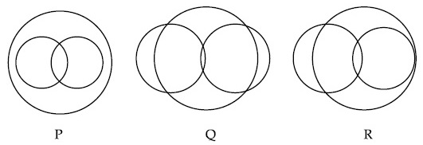
- Q and R (b) None of these
(c) P and R (d) P and Q

Q6: Let A = {2, 3, 4, 5, ....., 30} and '' be an equivalence relation on , defined by (a, b) (c, d), if and only if ad = bc. Then the number of ordered pairs which satisfy this equivalence relation with ordered pair (4, 3) is equal to :
- 5 (b) 6
(c) 8 (d) 7
Q7: The number of elements in the set is equal to:
- 4 (b) 2
(c) 3 (d) 1
Q8: Let R = {(P, Q) | P and Q are at the same distance from the origin} be a relation, then the equivalence class of (1, -1) is the set :
- (b)
(c) (d)

Q1 : Consider the two sets : both the roots of are real} and Which of the following is not true?
- (b)
(c) (d)
Q2 : Let , where each contains 10 elements and each contains 5 elements. If each element of the set T is an element of exactly 20 of sets ’s and exactly 6 of sets ’s then n is equal to
- 15 (b) 30
(c) 50 (d) 45
Q3 : A survey shows that 73% of the persons working in an office like coffee, whereas 65% like tea. If x denotes the percentage of them, who like both coffee and tea, then x cannot be :
- 63 (b) 54
(c) 38 (d) 36
Q4 : Let and then :
(a) (b)
(c) (d)
Q5: A survey shows that 63% of the people in a city read newspaper A whereas 76% read newspaper B. If x% of the people read both the newspapers, then a possible value of x can be:
- 37 (b) 65
(c) 29 (d) 55
Q6: Let R₁ and R₂ be two relation defined as follows :
R₁ = {(a, b) R² : a² + b² Q} and
R₂ = {(a, b) R² : a² + b² Q},
where Q is the set of all rational numbers. Then :
- Neither nor is transitive.
- is transitive but is not transitive
- and are both transitive
- is transitive but is not transitive
Q7: If R = {(x, y) : x, y Z, x² + 3y² 8} is a relation on the set of integers Z, then the domain of R^{–1} is :
- {0,1} (b) {-2,-1,1,2}
(c) {-1,0,1} (d) {-2,-1,0,1,2}

Q1 : Let A, B and C be sets such that . Then which of the following statements are not true?
- If then (b) If ,then
(c) (d)
Q2: Let The number of non-empty subsets A of S such that the product of elements in A is even is :
- (b)
(c) (d)
Q3: Let Z be the set of integers.
If and
, then the number of subsets of the set , is :
- (b)
(c) (d)
Q4: Two newspapers A and B are published in a city. It is known that 25% of the city populations reads A and 20% reads B while 8% reads both A and B. Further, 30% of those who read A but not B look into advertisements and 40% of those who read B but not A also look into advertisements, while 50% of those who read both A and B look into advertisements. Then the percentage of the population who look into advertisement is :-
- 13.5 (b) 13
(c) 12.8 (d) 13.9
Q5: In a class of 140 students numbered 1 to 140, all even numbered students opted Mathematics course, those whose number is divisible by 3 opted Physics course and those whose number is divisible by 5 opted Chemistry course. Then the number of students who did not opt for any of the three courses is
- 42 (b) 102
(c) 1 (d) 38

Q1: Let N denote the set of all natural numbers. Define two binary relations on N as R = {(x, y) N N : 2x + y = 10} and R₂ = {(x, y) N N : x + 2y = 10}. Then :
- Range of is {2,4,8}. (b) Range of is {1,2,3,4}.
(c) Both and are symmetric relations
(d) Both and are transitive relations
Q2: Two sets A and B are as under:
;
;
Then
- Neither nor (b)
(c) (d) (an empty set)
Q3: Consider the following two binary relations on the set A = {a, b, c} :
R₁ = {(c, a), (b, b), (a, c), (c, c), (b, c), (a, a)} and
R₂ = {(a, b), (b, a), (c, c), (c, a), (a, a), (b, b), (a, c)}.
Then
- Both and are not symmetric.
- is not symmetric but it is transitive.
- is symmetric but it is not transitive.
- Both and are transitive.

Q1: Let be two seats. Then
- and (b)
(c) (d)

Q1: Let A and B be two sets containing four and two elements respectively. Then the number of subsets of the set , each having at least three elements is:
(1) 256 (2) 275
(3) 510 (4) 219

1. If and , where N is the set of natural numbers, then is equal to
(1) N (2) Y – X
(3) X (4) Y

1. Let A and B be two sets containing 2 elements and 4 elements respectively. The number of subsets of having 3 or more elements is
(1) 220 (2) 219
(3) 211 (4) 256

1. Let S be a non-empty subset of R. Consider the following statement:
P: There is a rational number such that x > 0.
Which of the following statements is the negation of the statement P?
- There is no rational number such that
- Every rational number satisfies
- and is not rational
- There is a rational number such that
2. Consider the following relations:
R = {(x,y)|x,y are real numbers and x=wy for some rational number w};
S = Then
- neither R nor S is an equivalence relation
- S is an equivalence relation but R is not an equivalence relation
- R and S both are equivalence relations
- R is an equivalence relation but S is not an equivalence relation

1. If A, B nd C are three sets such that and , then
(1) A = B (2) A = C
(3) B = C (4)

1. Let R be the real line. Consider the following subsets of the plane .
S = {(x,y): y = x + 1 and 0 < x <2 }, T = {(x,y):x – y is an integer}. Which one of the following is true?
- neither S nor T is an equivalence relation on R
- Both S and T are equivalence relations on R
- S is an equivalence relation on R but T is not
- T is an equivalence relation on R but S is not

1. Let W denote the words in the English dictionary. Define the relation R by :
R = {(x,y)ε| the words x and y have at least one letter in common}. Then R is
- Not reflexive, symmetric and transitive (2) reflexive, symmetric and not transitive
(3) reflexive, symmetric and transitive (4) reflexive, not symmetric and transitive

1. Let R = {(3,3), (6,6), (9,9),(12,12),(6,12),(3,9),(3,12),(3,6)} be a relation on the set A = {3,6,9,12} be a relation on the set A = {3,6,9,12}. The relation is
(1) reflexive and transitive only (2) reflexive only
(3) an equivalence relation (4) reflexive and symmetric only

1. Let R = {(1,3),(4,2),(2,4),(2,3),(3,1)} be a relation on the set A = {1,2,3,4}. The relation R is
(1) a function (2) reflexive
(3) not symmetric (4) transitive

Q1: Let S be the set of the first 11 natural numbers. Then the number of elements in and the product of all elements of B is even } is __________.

Q1: The number of relations on the set , containing at most 6 elements including , which are reflexive and transitive but not symmetric, is __________.
Q2: For let denote the set of all subsets of with no two consecutive numbers. For example , but . Then is equal to __________.
Q3: Let be the set of first ten prime numbers. Let , where P is the set of all possible products of distinct elements of S . Then the number of all ordered pairs , such that x divides y, is __________.
Q4: Let . The number of relations on A, containing and , which are reflexive and transitive but not symmetric, is __________.

Q1: Let and . Let R be a relation defined on by if and only if . Then the number of elements in R is __________.
Q2: In a survey of 220 students of a higher secondary school, it was found that at least 125 and at most 130 students studied Mathematics; at least 85 and at most 95 studied Physics; at least 75 and at most 90 studied Chemistry; 30 studied both Physics and Chemistry; 50 studied both Chemistry and Mathematics; 40 studied both Mathematics and Physics and 10 studied none of these subjects. Let m and n respectively be the least and the most number of students who studied all the three subjects. Then m+n is equal to __________.
Q3: Let Let and be two relations on A such that is divisible by a} , is an integral multiple of b}. Then, number of elements in is equal to __________.
Q4: Let . Let R be a relation on A defined by if and only if . Let be a symmetric relation on A such that and the number of elements in is n. Then the minimum value of n is __________.
Q5: Let and be a relation on A. Let S be the equivalence relation on A such that and the number of elements in S is n. Then the minimum value of n is __________.
Q6: The number of symmetric relations defined on the set which are not reflexive is __________.

Q1: The number of elements in the set and is a multible of 7} is __________.
Q2: Let and R be a relation on the set defined by Then the number of elements in R is __________.
Q3: Let and or be a relation on A. Then the minimum number of elements, that must be added to the relation so that it becomes reflexive and symmetric, is __________.
Q4: The number of relations, on the set contaning and , which are reflexive and transitive but not symmetric, is __________.
Q5: The number of elements in the set is __________.
Q6: Let and R be a relation defined on A such that is odd positive integer or . The minimum number of elements that must be added to the relation R, so that it is a symmetric relation, is equal to __________.
Q7: Let and . The number of elements in the relaiton is __________.
Q8: Let S = {1, 2, 3, 5, 7, 10, 11}. The number of non-empty subsets of S that have the sum of all elements a multiple of 3, is __________.
Q9: The minimum number of elements that must be added to the relation R = {(a, b), (b, c), (b, d)} on the set {a, b, c, d} so that it is an equivalence relation, is __________.

Q1: Let and . If , then the sum of all the elements in the set T-A is equal to __________.
Q2: Let and . Then the number of elements in the set is __________.
Q3: Let . Define either or } and the sum of all the elements of T is a prime number }. Then the number of elements in the set is __________.
Q4: Let R₁ and R₂ be relations on the set {1, 2, ......., 50} such that
R₁ = {(p, p^{n}) : p is a prime and n0 is an integer} and
R₂ = {(p, p^{n}) : p is a prime and n = 0 or 1}.
Then, the number of elements in R₁ - R₂ is __________.
Q5: Let A = {n N : H.C.F. (n, 45) = 1} and
Let B = {2k : k {1, 2, ......., 100}}. Then the sum of all the elements of AB is __________.
Q6: Let and Then is equal to __________.
Q7: The sum of all the elements of the set is __________.

Q1: If and Z is the set of all integers, then the number of subsets of the set is __________.
Q2: Let and , then the sum of all the elements of the set is equal to __________.
Q3: Let is a 3-digit number} , and for some . If the sum of all the elements of the set is , then is equal to __________.

Q1: Set A has m elements and set B has n elements. If the total number of subsets of A is 112 more than the total number of subsets of B, then the value of m.n is __________.
Q2: Let . If is a multiple of 2} and is a multiple of 7}, then the number of elements in the smallest subset of X containing both A and B is __________.

1.1

Definition: If to every value (considered as real unless other-wise stated) of a variable x, which belongs to some collection
(Set) A, there corresponds one and only one finite value of the quantity y, then y is said to be a function (Single valued) of x or a dependent variable defined on the set A ; x is the argument or independent variable.
If to every value of x belonging to some set A there corresponds one or several values of the variable y, then y is called a multiple valued function of x defined on A.Conventionally the word "FUNCTION” is used only as the meaning of a single valued function, if not otherwise stated .
See a function as an operator, which takes an input and gives an output. The input is called the independent variable and the output, which depends on the input because of the operator, is called the dependent variable
Pictorially:
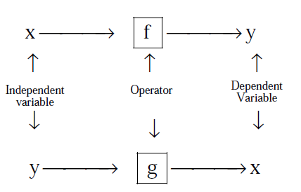
DOMAIN, CO-DOMAIN & RANGE OF A FUNCTION :
Let f : A → B, then the set A is known as the domain of f & the set B is known as co-domain of f . The set of all f images of elements of A is known as the range of f . Thus :
Domain of f = {a | a ∈ A, (a, f(a)) ∈ f}
Range of f = {f(a) | a ∈ A, f(a) ∈ B}
It should be noted that range is a subset of co-domain . Sometimes if only f (x) is given then domain is set of those values of ' x ' for which f (x) exists or is defined .

 Exercise1.1:

Q1: Given a function ,find
Q2: Given a function ,prove that ,and also find the value of .
Q3: if then evaluate
Q4: Given a function .show that at ,the following identity holds true.
Also prove that .

Q5: Given a function Find .
Q6: In the square ABCD with side AB=2 a straight line MN is drawn perpendicular to AC .Denoting the distance from the vertex A to the line MN as x ,express through the x the area S of triangle AMN cut off from line MN .Find the area at x=√2/2 and x=2.
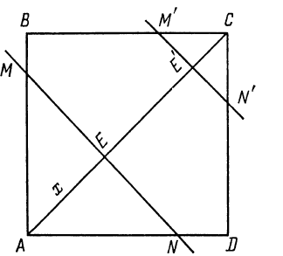
Q7: A function f satisfies the condition Determine it and hence find f(3)

Q8: An polynomial expression f(x) of degree n satisfies the condition then prove that
Q9: If for non zero x,where a≠b,then f(x) is equal to?
Q10: Let for all x ∈R and for all n≥2.Then find .
Q11: If ,for x>0,Find
Q12: If where [x] stands for the greatest integer function, then evaluate
f (π / 2), f (π), f (−π) and f (π / 4) .

Graphs of fuctions
1.2

S.NO | FUNCTION |  | GRAPH | DOMAIN | RANGE
a) | Constant function | f(x)=k | 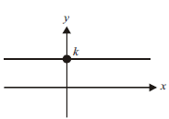 |  | {k}
b) | Identity function | f(x)=x | 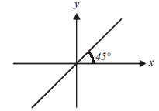
c) | Linear function | f(x)=mx+c | 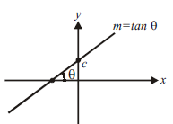
d) | Square function | f(x)=x² | 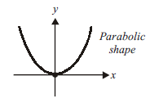 |  | [0,∞)
e) | Cube function | f (x) = x³ | 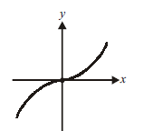
f) | Reciprocal function | f (x)=1/x | 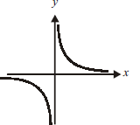
g) | Modulus Function |  | 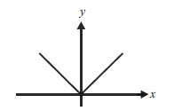 |  | [0,∞)
h) | Exponential function |  | 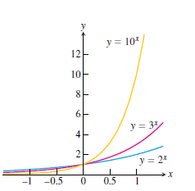 |  | (0,∞)
 |  |  | 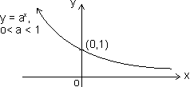 |  | (0,∞)
i) | Logarithmic function |  | 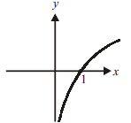 | (0,∞)
 |  |  | 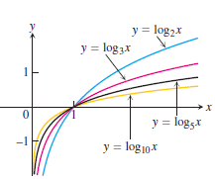 | (0,∞)
 |  |  | 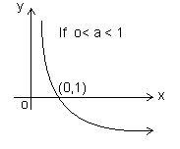 | (0,∞)
j) | Greatest integer function |  | 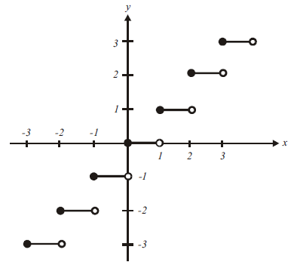
k) | Fractional part |  | 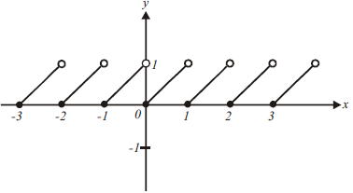 |  | [0,1)
l) | Square root |  | 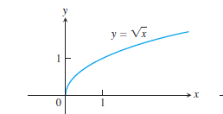 | [0,∞) | [0,∞)
m) | Cube root |  | 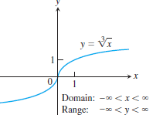
n) | Signum function |  | 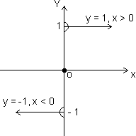 |  | {- 1, 0,1}

TRIGNOMETRIC FUNCTIONS
 | FUNCTION | PERIOD | GRAPH | DOMAIN | RANGE
a) | sinx | 2𝝅 | 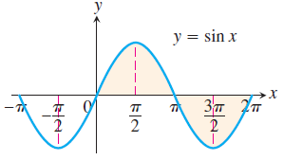 |  | [-1,1]
b) | cosx | 2𝝅 | 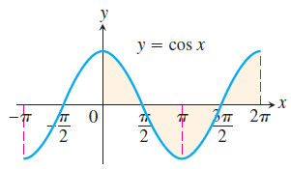 |  | [-1,1]
c) | tanx | 𝝅 | 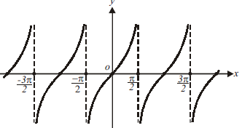
d) | cosecx | 2𝝅 | 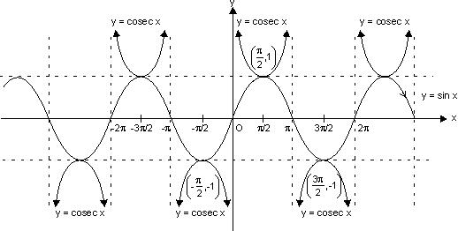
e) | secx | 2𝝅 | 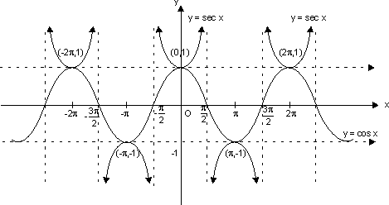
f) | cotx | 𝝅 | 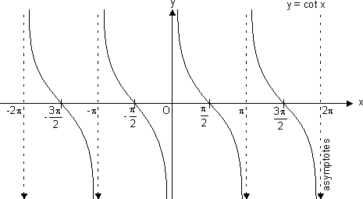

INVERSE TRIGNOMETRIC FUNCTIONS
 | FUNCTION | GRAPH | DOMAIN | RANGE
a) |  | 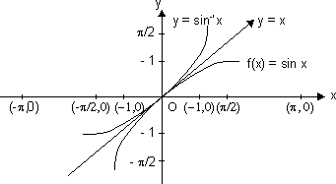 | [-1, 1]
b) |  | 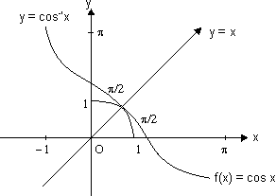 | [-1, 1]
c) |  | 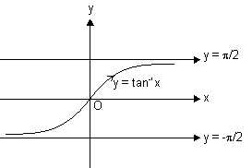
d) |  | 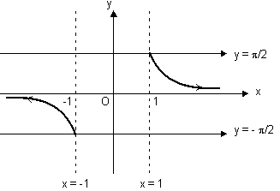
e) |  | 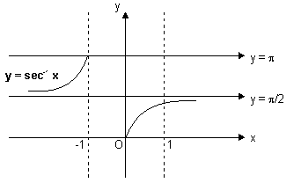
f) |  | 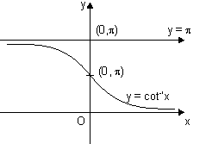
g) | sin(sin⁻¹x) | 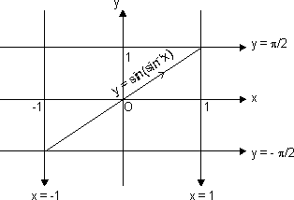 | [-1, 1] | [-1, 1]
h) | cos(cos⁻¹x) | 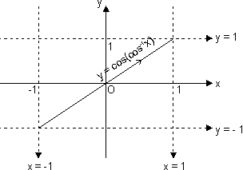 | [-1, 1] | [-1, 1]
i) | tan(tan⁻¹x) | 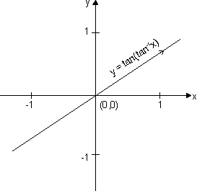
j) | cosec(cosec⁻¹x) | 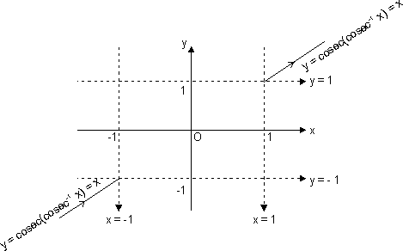
k) | sec(sec⁻¹x) | 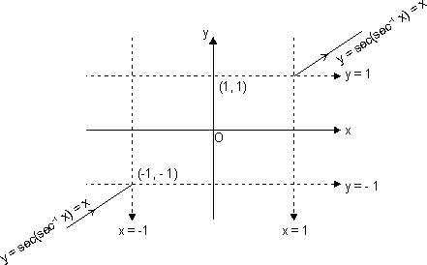
l) | cot(cot⁻¹x) | 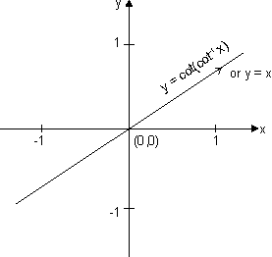

Properties,domain and range
1.3

Properties of some standard functions:
1. Properties of modulus function:
(i) |x| a - a x a (a 0)
(ii) |x| a x - a or x a (a )
(iii) |x + y| |x| + |y|
(iv)
2. Properties of greatest integer function:
(i) [x] = x holds if x I (I is Integer).
(ii) [x + I] = [x] + I if I is integer.
(iii) [x + y] [x] + [y]
(iv) If [(x)] I, then (x) I.
(v) If [(x)] I, then (x) < I + 1
(vi) If [x] > n x n + 1, n I.
(vii) [- x] = - [x] if x I
& [- x] = - [x] - 1 if x I.
(viii) [x + y] = [x] + [x + y - [x]] for all x, y R.
(ix) [x] + 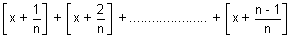
= [n x], n N N natural no.
3. Properties of fraction part of x
(i) {x} = x if 0 x< 1
(ii) {x} = 0 if x I
(iii) {- x} = 1 - {x} if x I
4. Properties of logarithmic function:
(i) log_{a}a = 1 (a>0,a≠1)
(ii) log_{e}(ab)= log_{e}a+ log_{e}b (a,b>0)
(iii) log_{e}(a/b)= log_{e}a- log_{e}b (a,b>0)
(iv) log_{e}a^{m}=m log_{e}a (a>0,m∈R)
(v) log_{b}a=1/( log_{a}b) (a,b>0 and a,b≠1)
(vi) log_{b}a= log_{m}a/ log_{m}a (a,b,m>0 ≠1)
(vii) (a>0,a≠1;m>0)
(viii)
(ix)
(x)
(xi) (m,a>0;m≠1b∈R)

 Exercise1.2:
Q1: Solve the following equations:

 Exercise1.3:
Q1: Find the domains of the following functions, assuming the functions to be real for given

Q2: Find the domain of single valued function y = f(x) given by the equation

 Exercise1.4:
Q1: Find the range of the following functions, assuming real functions given by

- x

Analysis of a function
1.4

Even and odd functions
Definition: A function y=f(x) is an
Even function of x if
Odd function of x if
Graphs of even function are symmetric about y axis ,example
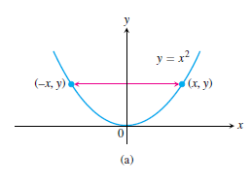
Graphs of odd function are symmetric about origin ,example
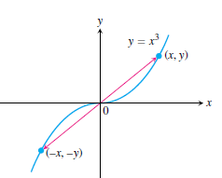

Increasing and decreasing function:
If the graph of a function climbs or rises as you move from left to right, we say that the function is increasing. If the graph descends or falls as you move from left to right, the function is decreasing

If function is strictly increasing
If function is increasing

If function is strictly deccreasing
If function is decreasing

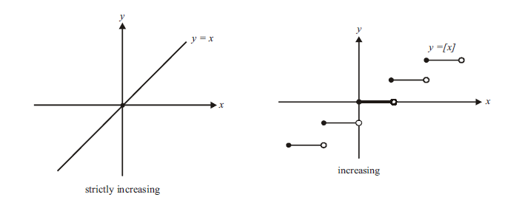
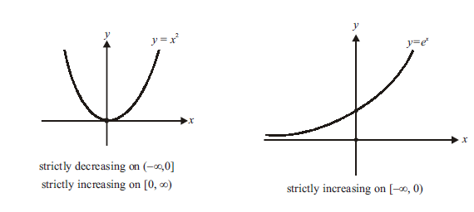
Periodic function:
A function ƒ(x) is periodic if there is a positive number T such that for every value of x. The smallest such value of T is the period of ƒ.
For example, sin x has periods 2π , 4π ,6π , −4π , 2nπ etc. but the fundamental period is 2π.

Properties of periodic function:
(i) If f(x) is periodic with period T, then, c.f(x), f(x + c) & f(x) ± c is periodic with period T.
eg. if sin x has period 2. Then f(x) = 5 sinx + 4 is also periodic with period 2.
(ii) If f(x) is periodic with period T, then, kf(cx + d) has period
f(x) = 7 sin2x - 12 has period as sinx is periodic with period .
(iii) If f₁(x), f₂(x) are periodic functions with periods T₁, T₂ respectively then; h(x) = af₁(x) ± bf₂(x) has period as
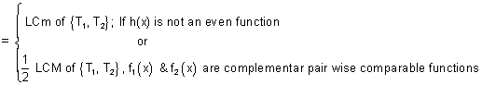
LCM of 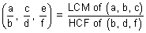
Note: LCM of rational and irrational is not possible. eg. 2. is irrational & 1 is rational.
Composite Function:
Let two function,
f : x Y₁ and g : Y₁ Y
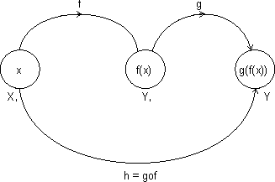
Let another function h : X Y
Such that
h(x) = g(f(x)) = (gof)(x)
domain (gof) = {x : x domain (f), f(x) domain (a)}
domain fog(x) = {x : x domain (g), g(x) domain f}
gof exist iff range of f domain of g
fog exist iff range of g domain of f.
Properties of composite function:
(i) f is even, g is even fog is even function.
(ii) f is odd, g is odd fog is odd function.
(iii) f is even, g is odd fog is even function.
(iv) f is odd, g is even fog is even function.
 Exercise1.5:
Q1: Check weather the following functions are even or odd
Q2: If the function f satisfies f (x + y) + f (x − y) = 2 f (x). f ( y) ∀ x, y∈R, and f (0)≠ 0, prove that f (x) is even.
Q3: If f is non-periodic and g is periodic, what can you say about f (
g(x)) and g ( f (x))?
Q4: What are the periods of the following functions f(x)=
Q5: Prove that if f is increasing, f ⁻¹ is increasing and if f is decreasing, f ⁻¹ is decreasing
Q6: If and then find the interval in which g(f(x) is invertible?
Q7: If ∀ real x,y and then prove that the function is an even function.
Q8: If is given by ,then find (assuming bijective)
Q9: If is given by ,then find (assuming bijective)
Q10: Find the inverse of the following functions (assuming bijective)
Q11: If and . Then find

Mapping of a Function:
Mapping of function: A function exists only if,” to every element in domain there exists unique image in co domain.
f : A B
One - One Mapping (Injective): A function f: A B is said to bwe one-one mapping if different elements of A have different images in B. no two elements of set A can have same 'f' image
eg.
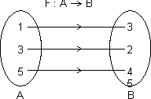
f(x) is one-one
Methods to find one-one mapping:
(1) Graphically: A fun. is one-one if no line 11 to x-axis meets graph of function at more than one point.
By Calculus: If f(x) is function and if f'(x) 0 v x domain i.e. increasing or f'(x) 0 v x domain i.e. decreasing, then one-one.
No. of one-one Mapping: If A & B are finite sets having m & h elements, then, no. of one-one function from A to B
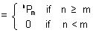
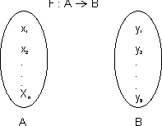
Many one Mapping: A mapping f : A B is many one if two or more elements of set A have the same image in B.
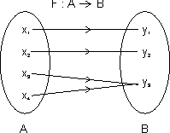
i.e. f(x³) = f(x₄) = y₃
Onto Function (Surjective): If function f : A B is such that each element of B is the 'f' image of at least one element in A.
i.e. range of f = co domain f(A) = B
Into Function: A function of f : A B is into if there exists an element in B having no pre image in A.
No. of one-one onto mapping (bijection): If A & B are finite sets & f : A B is a bijection.
Then A & B have same no. of elements.

Total no. of bijection A B = n !
Inverse function: Let f : A B be one-one & onto function then there exists a unique function.
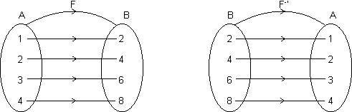
g : B A such that f(x) = y g(y) = x, v x A & y B
Then g is c/d inverse of F.
So, g = f⁻¹ : B A = {(f(x), x) | (x, f(x) f}
Domain of f = {1, 2, 3, 4} = range of f⁻¹
Range of f = {2, 4, 6, 8} = domain of f⁻¹.
Note: (1) Graph of y = f(x) and y = f⁻¹(x) are mirror images to each other.
(2) If f : A B & g : B C are two bijections, then gof : A C is bijection & (gof)⁻¹ = (f⁻¹og⁻¹).
(3) If fog = gof then either f⁻¹ = g or g⁻¹ = f and (fog)(x) = (gof)(x) = (x)
 Exercise1.6:
Q1: Is one one or many one?
Q2: Is one one or many one?

Q3: Are the following functions into or onto?

 Exercise level 1:
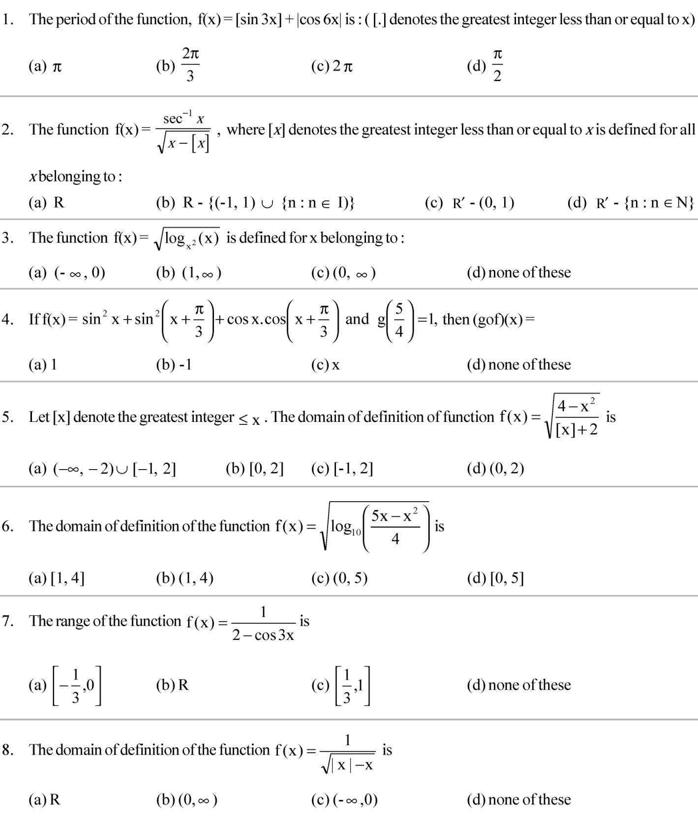
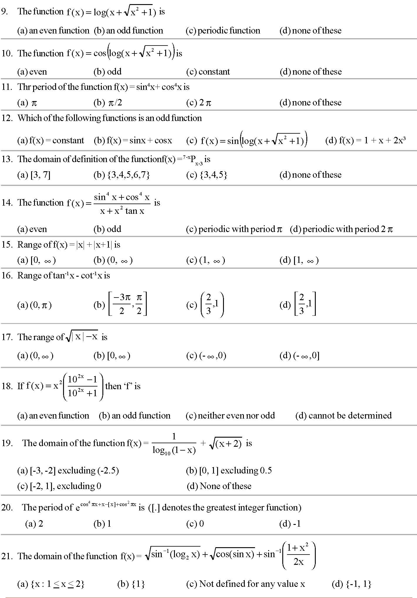
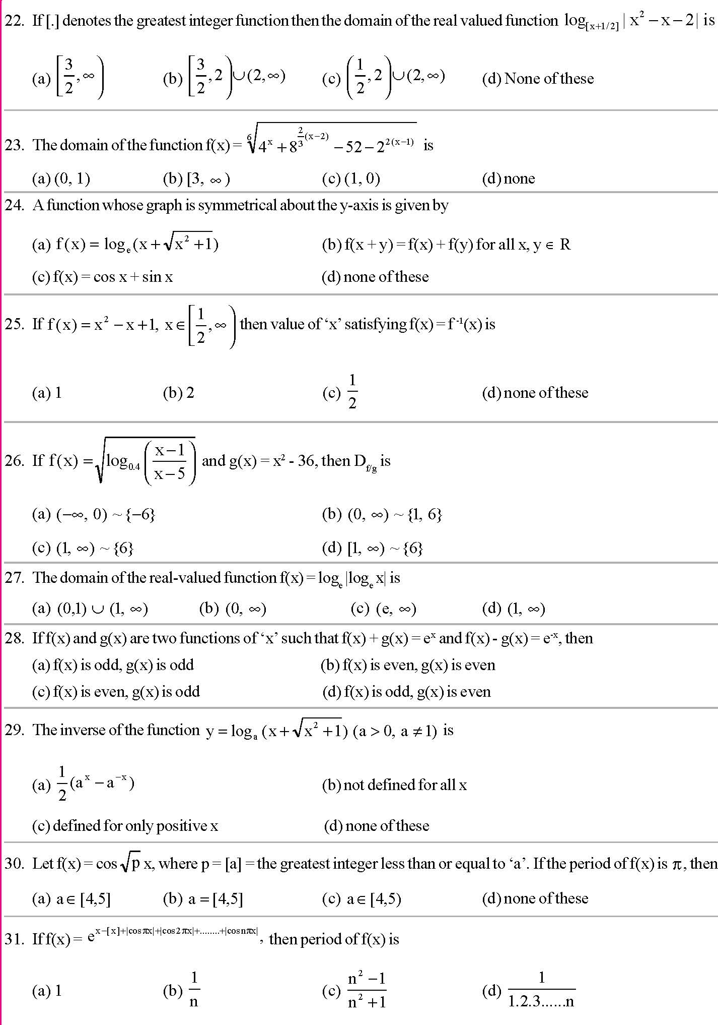
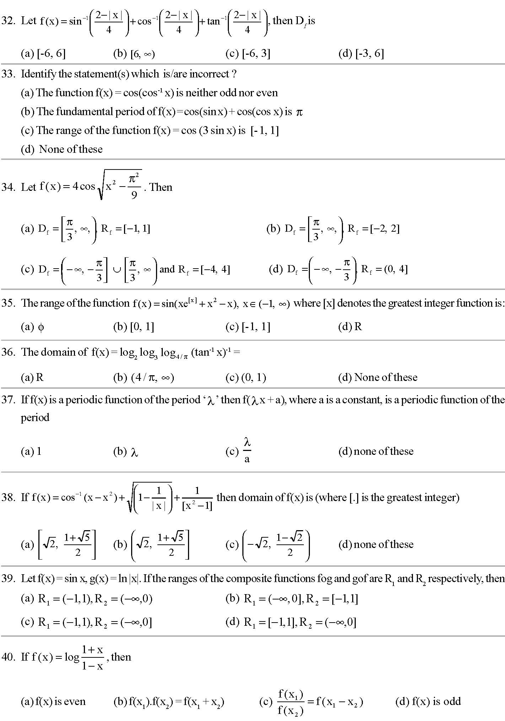
 Exercise level 2:
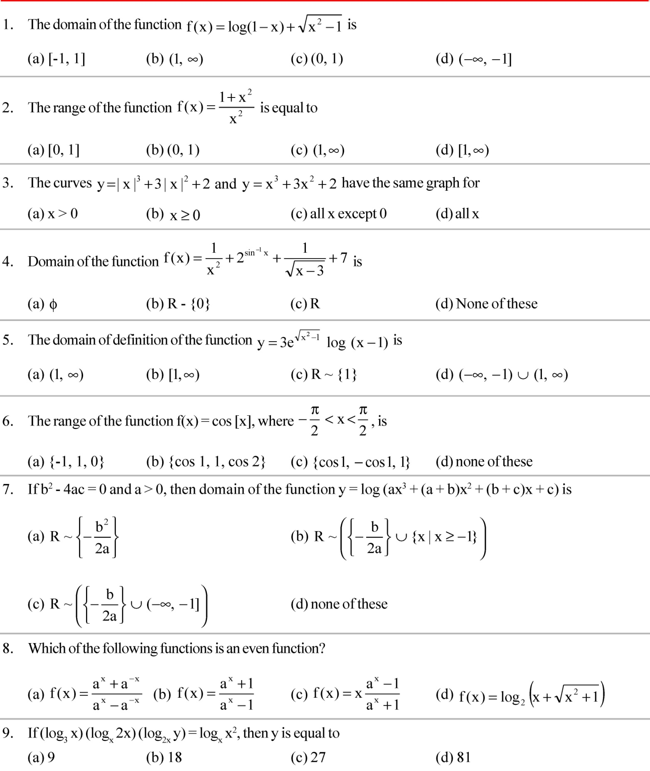
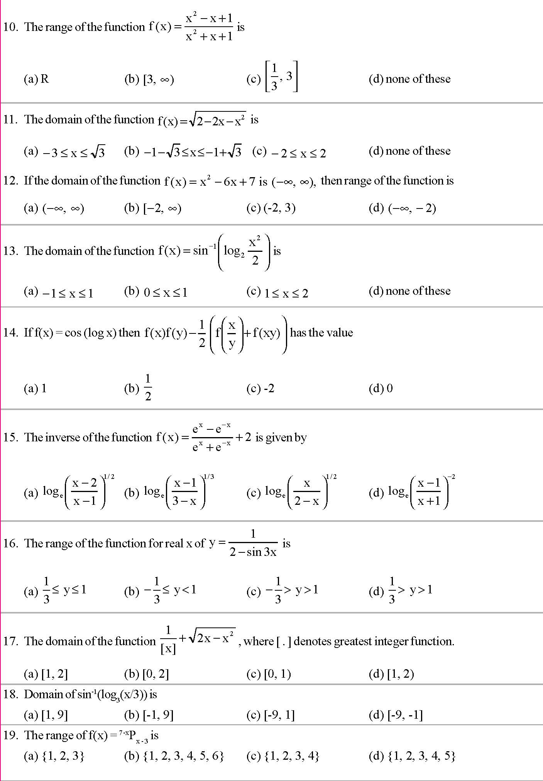
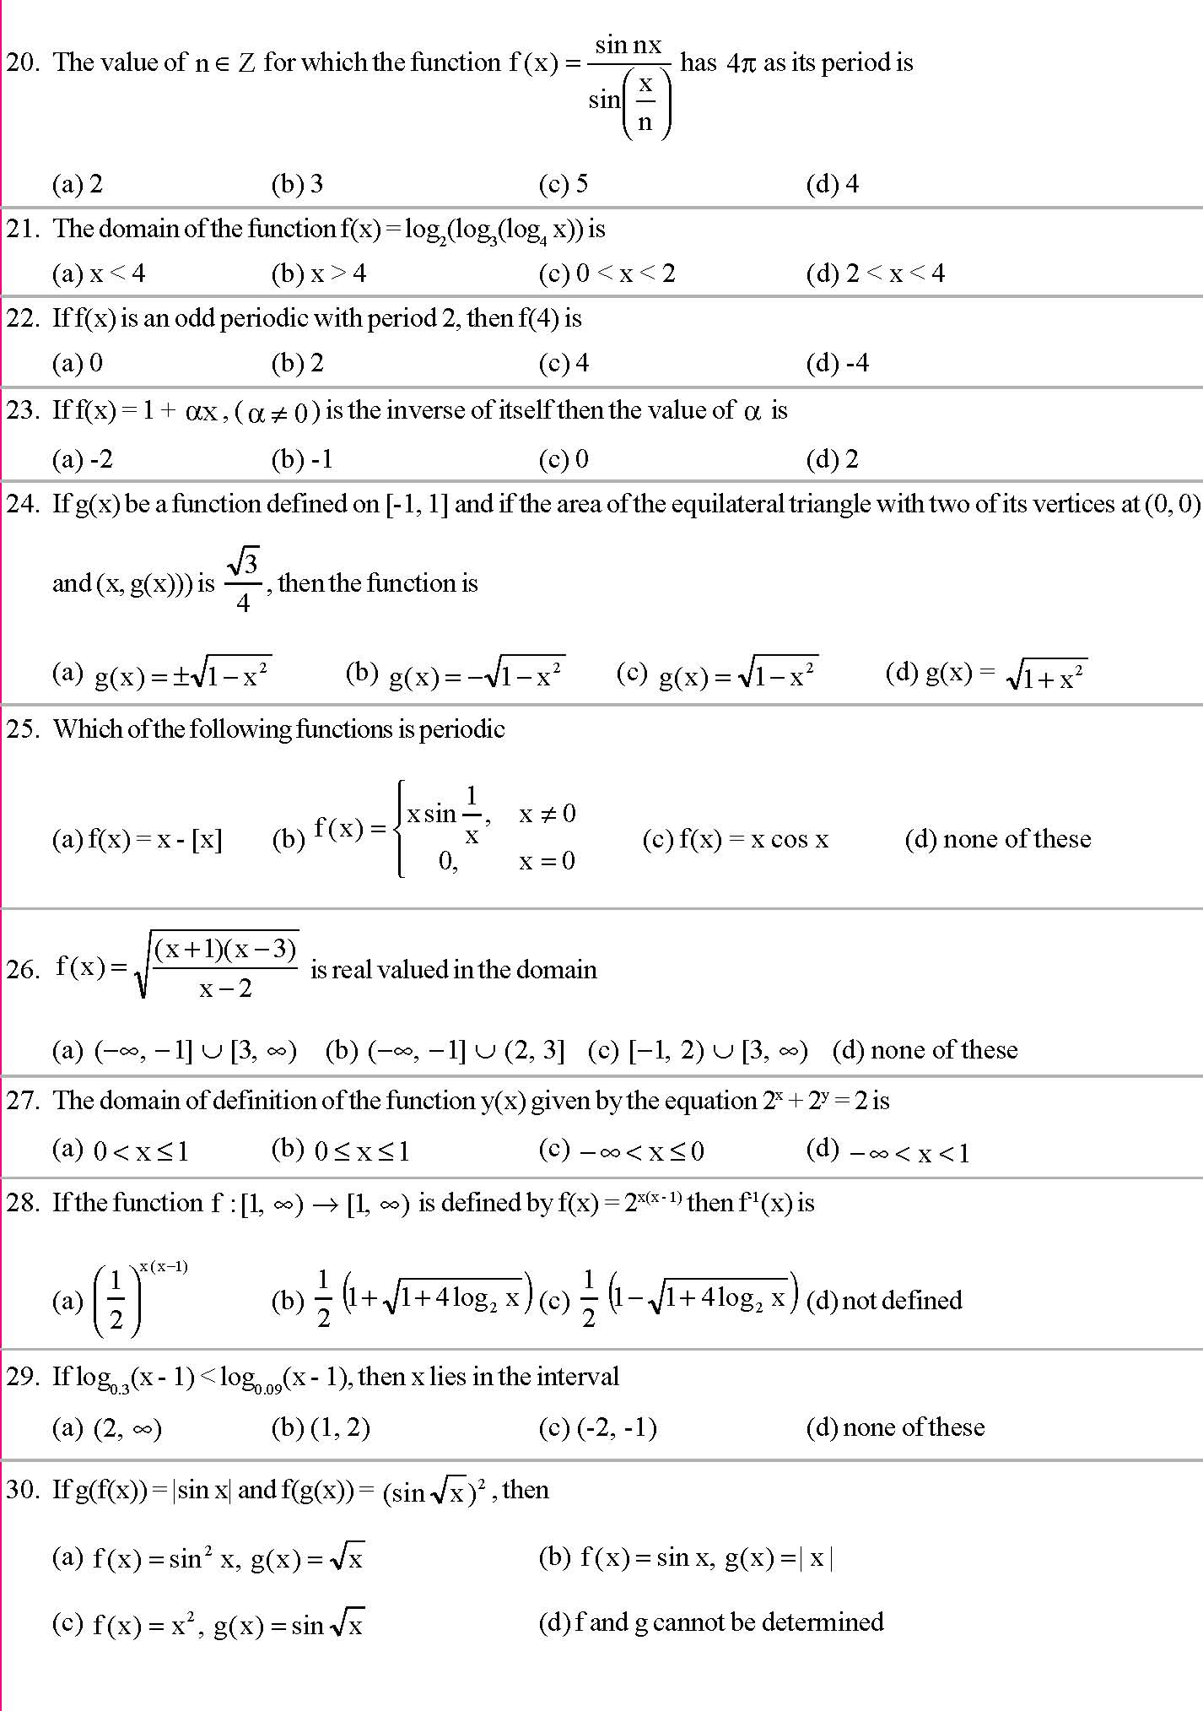
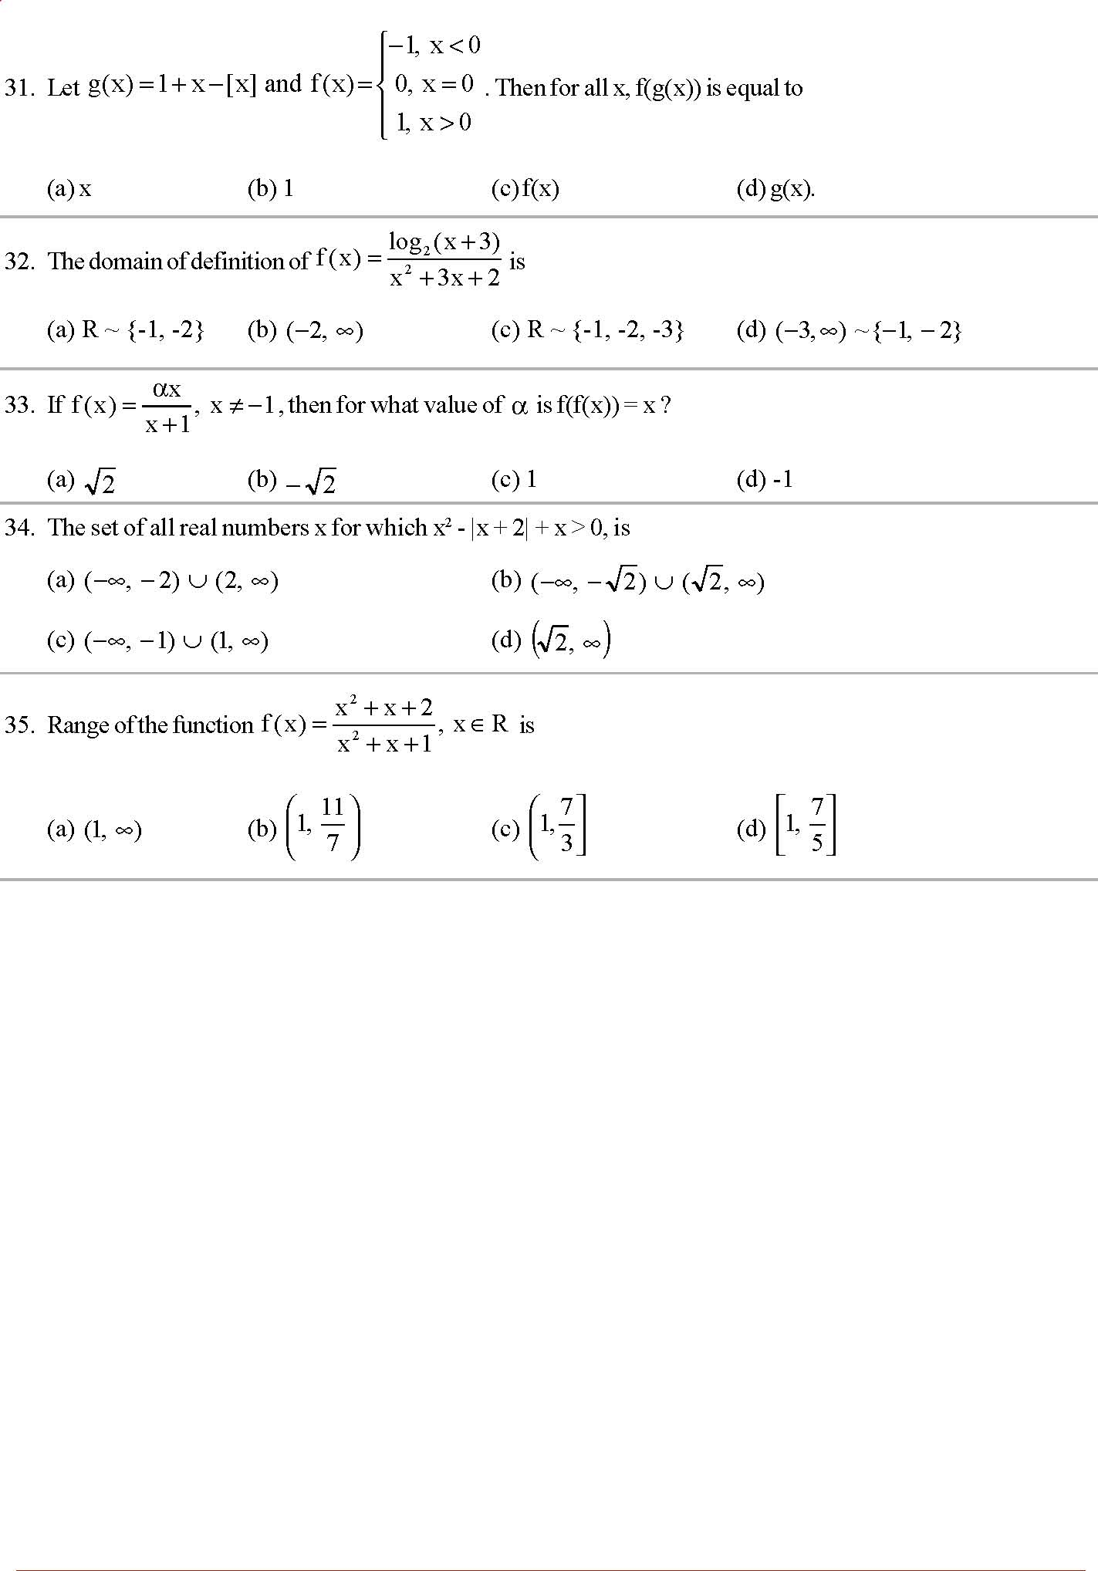
 Exercise level 3 :
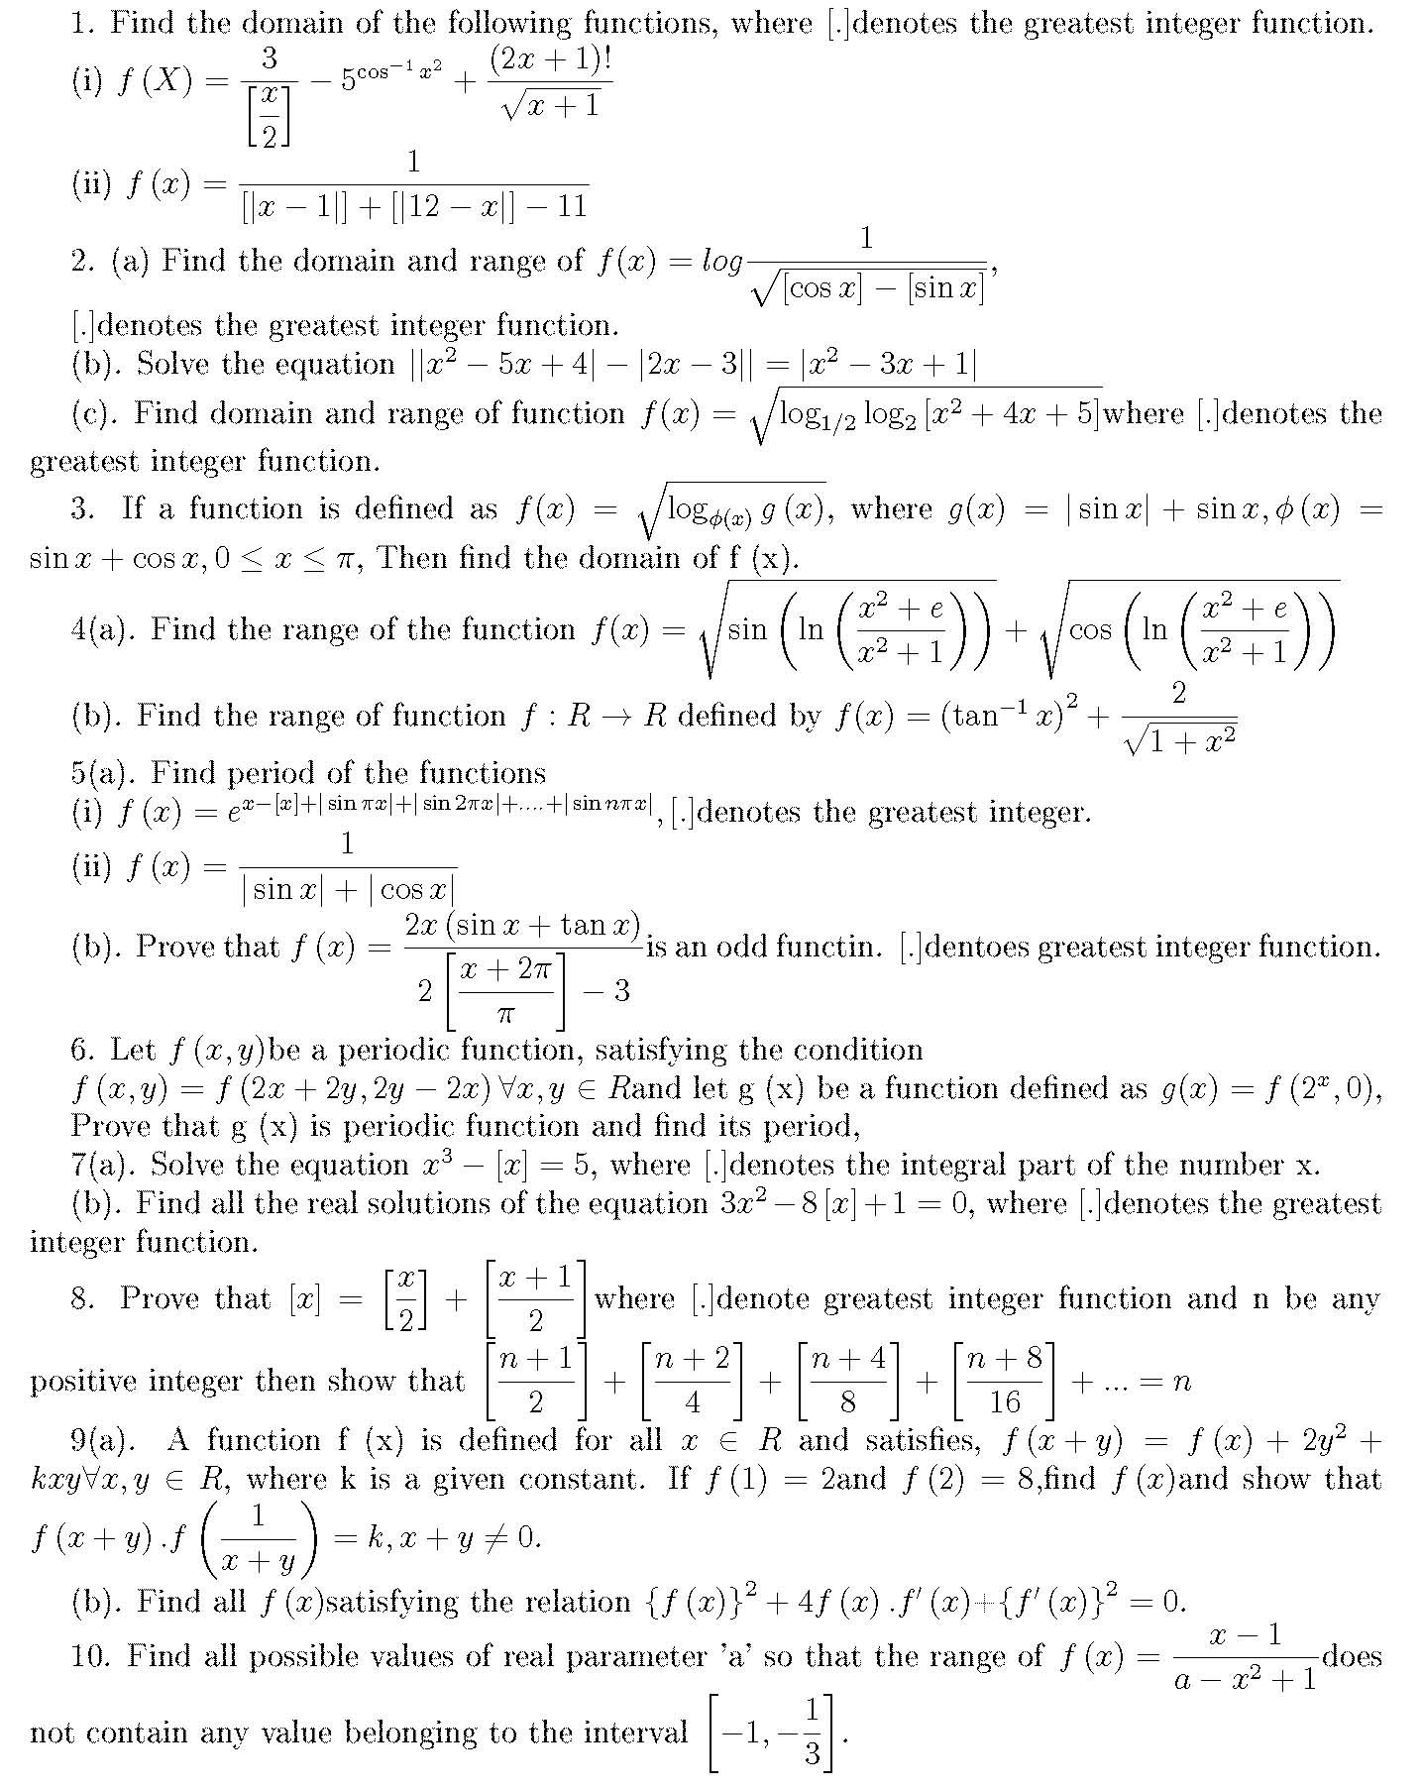

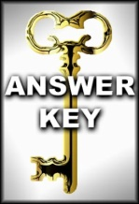 Exercise level 1 :
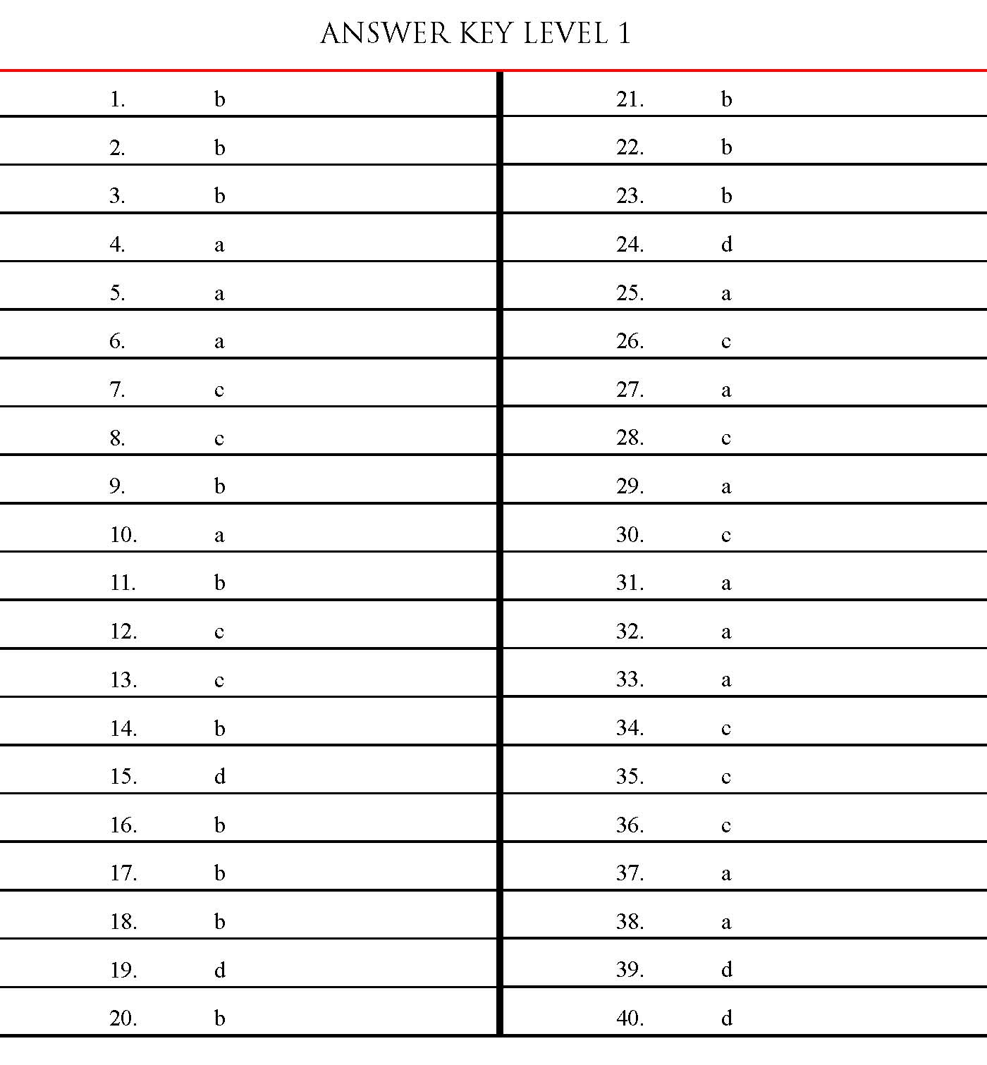

 Exercise level 2:
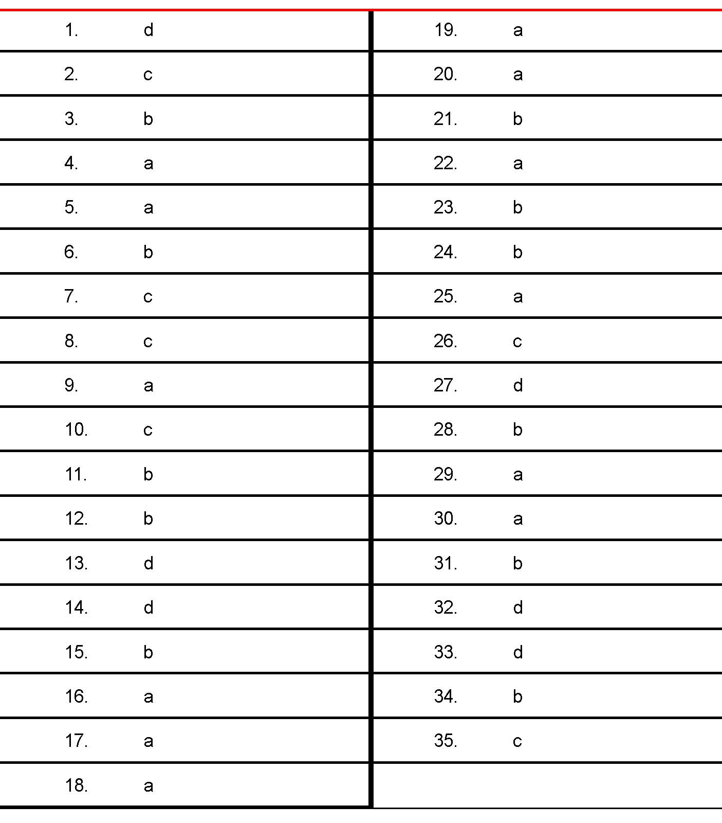

Q1: Let denote the set of all real numbers. Let and be functions defined by , and
Define the composite function by , where is the inverse of function . Then the value of derivative of the composite function at is __________.
Q2: Let denote the set of all real numbers. Let be a function such that for all , and for all . Let the real numbers be in an arithmetic progression. If , and , then the value of is __________.

Q1: Let be a function such that for all and be a function such that for all . If and , then the value of is __________.
Q2: Let the function be defined by Then the number of solutions of in is __________.

Q1: Let the function be defined by . Then the value of is __________.
Q2: Let the function be defined by . Suppose the function has a local minimum at precisely when , where Then the value of is __________.
Q3: Let be a function defined by . If are such that, then the value of is __________.
Q4: For a polynomial g(x) with real coefficients, let m_{g} denote the number of distinct real roots of g(x). Suppose S is the set of polynomials with real coefficients defined by
For a polynomial f, let f' and f'' denote its first and second order derivatives, respectively. Then the minimum possible value of (m_{f'} + m_{f''}), where , is __________.

Q1: Let X be a set with exactly 5 elements and Y be a set with exactly 7 elements. If is the number of one-one functions from X to Y and is the number of onto functions from Y to X, then the value of is __________.

Q1: If the function and , then the value of is __________.

Q1: Let ℕ denote the set of all natural numbers, and ℤ denote the set of all integers. Consider the functions f: ℕ → ℤ and g: ℤ → ℕ defined by
and
Define for all and for all .
Then which of the statements is (are) true?
- is NOT one-one and gof is NOT onto.
- is NOT one-one but is onto.
- g is one-one and g is onto.
- f is NOT one-one but f is onto.

Q1: Let and . Then which of the following statements is(are) true?
- There are infinitely many functions from S to T.
- There are infinitely many strictly increasing functions from S to T.
- The number of continuous functions from S to T is is at most 120.
- Every continuous function from S to T is differentiable.
Q2: Let be the function defined by Consider the square region . Let be called the green region and
be called the red region. Let be the horizontal line drawn at a height . Then which of the statements is(are) true?
- There exists an such that the area of the green region above the line equals the area of the green region below the line .
- There exists an such that the area of the red region above the line equals the area of the red region below the line .
- There exists an such that the area of the green region above the line equals the area of the red region below the line .
- There exists an such that the area of the red region above the line equals the area of the green region below the line .

Q1: Let denote the determinant of a square Matrix M. Let be the function defined by where . Let be a quadratic polynomial whose roots are the maximum and minimum values of the function , and . Then which of the following is (are) true?
- (b)
(c) (d)

Q1: Let for all and for all . Let denote and denote . The which of the following is/are true?
- Range of f is (b) Range of is
(c) (d) There is an such that .

Q1: For every pair of continuous function such that . The correct statements is(are)
- for some
- for some
- for some
- for some
Q2: Let be given by .Then,
- is an odd function (b) is a one-one function
(c) is an onto function (d) is an even function

Q1: Let be such that for . Then the value(s) of is(are):
- (b)
(c) (d)

Q1: Let be defined by , where is a constant such that Then
- is not invertible on
- on and .
- on and .
- is differentiable on .

Q1: If the function is defined by , then which of the following statements is TRUE?
- f is one-one, but NOT onto.
- f is onto, but NOT one-one.
- f is BOTH one-one and onto.
- f is NEITHER one-one NOR onto.

Q1: Let and .
(Here the inverse trigonometric functionassumes values in .).Let be the function defined by and be the function defined by .
List-I | List-II
P. The range of f is | 1.
Q. The range of g contains | 2.
R. The domain of f contains | 3.
S. The domain of g is | 4.
 | 5.
 | 6.

The correct option is:

Q1: Let . For ,let be the number of subsets of S, each containing five elements out of which exactly k are odd. Then
- 210 (b) 252
(c) 126 (d) 125

Q1: Let ,, and be defined by
;
and
List-I | List-II
P. is | (i) onto but not one-one
Q. is | (ii) neither continuous nor one-one
R. is | (iii) differentiable but not one-one
S. is | (iv) continuous and one-one

Q1: The function , defined by , is
- one-one and onto. (b) onto but not one-one.
(c) one-one but not onto. (d) neither one-one nor onto.

Q1: Let and for all . Then the set of all satisfying where , is
- (b)
(c) (d)
Q2: Match the statements given in Column I with the intervals/union of intervals given in Column II:
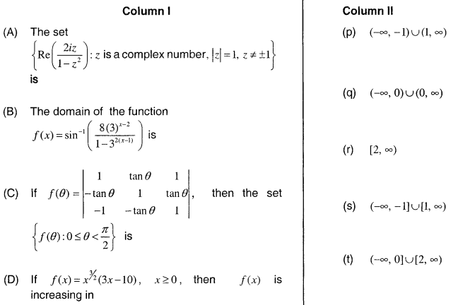

Q1: Let and be real valued functions defined on the interval by
and .
If a, b and c denote, respectively, the absolute maximum of and on , then
- and (b) and
(c) and (d)
Q2: Let The total number of unordered pairs of disjoint subsets of S is equal to :
- 25 (b) 34
(c) 42 (d) 41

Q1: If and and and and given that , then is equal to:
- 5 (b) 10
(c) 0 (d) 15

Q1: Find the range of value of t for which
- (b)
(c) (d)

Q1: Given below are two statements:
Statement I : The function defined by is one-one.
Statement II: The function defined by is many-one.
In the light of the above statements, choose the correct answer from the options given below :
- Statement I is true but Statement II is false.
- Both Statement I and Statement II are false.
- Both Statement I and Statement II are true.
- Statement I is false but Statement II is true.
Q2: The sum of all the elements in the range of , ,, where
is:
- 4 (b) 0
(c) 2 (d) -2
Q3: If and then is equal to:
- (b)
(c) (d)
Q4: Let be a function such that where . Then is equal to
- 36 (b) 9
(c) -9 (d) 18
Q5: Let , where is the greatest integer function. Then
- for finitely many values of x.
- only for .
- only for
Q6: Let the domain of the function + be . Then is equal to:
- 12 (b) 8
(c) 10 (d) 9
Q7: Let and be functions satisfying , and , for all . If then n is equal to:
- 6 (b) 7
(c) 4 (d) 5
Q8: If the domain of the function is , then is equal to
- 66 (b) 68
(c) 70 (d) 67

Q1: If the range of the function is . Then is equal to
- 188 (b) 192
(c) 190 (d) 194
Q2: Let the domains of the functions and be and respectively. Then is equal to:
- 15 (b) 13
(c) 16 (d) 14
Q3: Let be defined as and . If the range of the function is , then is equal to
- 56 (b) 2
(c) 29 (d) 68
Q4: Let f be a function such that The is
- 13 (b) 11
(c) 10 (d) 12
Q5: If the domain of the function is , then is equal to
- 17 (b) 15
(c) 16 (d) 18
Q6: If the domain of the function is , then is equal to
- 4 (b) 3
(c) 7 (d) 5
Q7: If the domain of the function is , then is equal to:
- 29 (b) 30
(c) 25 (d) 26
Q8: If the domain of the function is and the domain of the function is , then is equal to
- 186 (b) 179
(c) 195 (d) 174
Q9: Let be defined by and be defined by , If both the functions are onto and or then is equal to:
- 29 (b) 31
(c) 30 (d) 36
Q10: If ,, then is equal to
- 82 (b)
(c) 41 (d)
Q11: Let be a function defined by
If , then the value of is
- 735 (b) 675
(c) 715 (d) 545
Q12: The function , defined by is :
- One-one but not onto.
- Onto but not one-one.
- Both one-one and onto.
- Neither one-one nor onto.
Q13: Let Then the value of is equal to
- 108 (b) 92
(c) 118 (b) 102
Q14: Let and . Then the domain of is
- (b)
(c) (d)
Q15: Let and . Then the number of many-one functions such that is equal to:
- 151 (b) 139
(c) 163 (d) 127

Q1: Let the range of the function ,be . If and are respectively the A.M. and the G.M. of a and b, then is equal to
- (b)
(c) (d) 2
Q2: If the domain of the function is , the is equal to
- 40 (b) 36
(c) 24 (d) 32
Q3: Let where and . Then the function is
- Neither one-one nor onto.
- Both one-one and onto.
- One-one.
- Onto.
Q4: If the function attains the maximum value at then :
- (b)
(c) (d)
Q5: Let be a function defined on . Then the range of the function is equal to
- (b)
(c) (d)
Q6: The function is
- Both one-one and onto.
- Onto but not one-one.
- Neither one-one nor onto.
- One-one but not onto.
Q7: Let be defined as and . Then the function is
- neither one-one nor onto.
- One-one but not onto.
- Both one-one and onto.
- Onto but not one-one.
Q8: Let and . Then the total number of one-one maps , such that , is :
- 120 (b) 180
(c) 240 (d) 480
Q9: If the domain of the function is , then is equal to :
- 140 (b) 175
(c) 125 (d) 150
Q10: Let and be defined as and Then is:
- One-one but not onto. (b) neither one-one nor onto.
(c) Onto but not one-one. (d) both one-one and onto.
Q11: If , and , where , then is equal to
- -4 (b)
(c) (d) 4
Q12: If the domain of the function is , then the value of is equal to
- 9 (b) 12
(c) 11 (d) 10
Q13: If the domain of the function is , then is equal to
- 11 (b) 12
(c) 9 (d) 8
Q14: If , , then range of is
- (b)
(c) (d)
Q15: Let and be defined as and . Then the domain of the function is
- (b)
(c) (d)
Q16: The functions ; defined by the highest prime factor of n, is :
- One-one only (b) neither one-one nor onto.
(c) onto only (d) both one-one and onto

Q1: The range of is
- (b)
(c) (d)
Q2: For , two real valued functions and are such that, and . Then is equal to
- 5 (b) 0
(c) -3 (d) 1
Q3: Let D be the domain of the function . If the range of the function defined by ( [x] is the greatest integer function), is then is equal to
- 45 (b) 136
(c) 46 (d) nearly 135
Q4: The domain of the function is : (where [x] denotes the greatest integer less than or equal to x )
- (b)
(c) (d)
Q5: If then the least value of is :
- 2 (b) 4
(c) 0 (d) 8
Q6: Let the sets A and B denote the domain and range respectively of the function where denotes the smallest integer greater than or equal to x
Then among the statements
(S1):and
(S2):
- Only (S2) is true (b) Only (S1) is true
(c) Neither (S1) nor (S2) is true (d) Both (S1) and (S2) are true
Q7: Let be a function such that Then is equal to
- (b)
(c) (d)
Q8: Let If and respectively are the maximum and minimum values of , then
- (b)
(c) (d)
Q9: Let be real valued function defined as . Then range of is
- (b)
(c) (d)
Q10: The absolute minimum value, of the function where denotes the greatest integer function, in the interval , is :
- (b)
(c) (d)
Q11: If the domain of the function where [x] is the greatest integer , is , then it’s range is
- (b)
(c) (d)
Q12: The range of the function is :
- (b)
(c) (d)
Q13: Consider the function , satisfying with . Then is equal to
- 8000 (b) 8400
(c) 8100 (d) 8200
Q14: The domain of is
- (b)
(c) (d)
Q15: Let be a function such that . Then
- is many-one in (b) is one-one in
(c) is one-one in but not in
(d) is many-one in
Q16: The number of functions satisfying is
- 2 (b) 3
(c) 1 (d) 4
Q17: Let be a function defined by for some m, such that the range of is . Then the value of m is
- 4 (b) 3
(c) 5 (d) 2
Q18: Let , and Then the sum of all the positive integer divisors of is
- 60 (b) 58
(c) 61 (d) 59
Q19: Let be a function such that for all . If and then the value of n is
- 9 (b) 7
(c) 6 (d) 8
Q20: If , then is equal to
- 2011 (b) 2010
(c) 1010 (d) 1011

Q1: Let be such that , and If , then is equal to
- -4 (b)
(c) (d) 4
Q2: Let and be three positive real numbers. Let and be such that for all . If be in arithmetic progression with mean zero, then the value of is equal to
- 0 (b) 3
(c) 9 (d) 27
Q3: Let be functions defined by , where is the maximum of the powers of those primes such that divides a, and , for all . Then , the function
- One-one but not onto (b) Onto but not one-one
(c) both one-one and onto (d) neither one-one nor onto

Q4: The number of bijective functions such that , is
- (b)
(c) (d)
Q5: The total number of functions such that , is equal to:
- 60 (b) 90
(c) 108 (d) 126
Q6: Let the function be defined by , then f is
- One-one but not onto (b) onto but not one-one
(c) neither one-one nor onto (d) one-one and onto
Q7: Let be defined as and be defined as . Then the function fog is :
- One-one but not onto (b) onto but not one-one.
(c) Both one-one and onto (d) neither one-one nor onto
Q8: Let , . If for all , then is equal to:
- (b)
(c) (b)
Q9: Let be a function such that for natural numbers x and y. If then the value of for which holds, is
- 2 (b) 3
(c) 4 (d) 6
Q10: Let and be two functions defined by and . Then, for which of the following range of , the inequality holds?
- (b)
(c) (d)

Q1: The range of the function, is
- (b)
(c) (d)
Q2: Let be a function such that for every . If Then is equal to
- 6 (b) 54
(c) 18 (d) 36
Q3: Let be defined as Then, the value of is equal to:
- (b)
(c) (d)
Q4: Consider the function and such that exists, then
- and both are one-one (b) and both are onto
(c) is one-one and g is onto (d) is onto and is one-one
Q5: Let g : N → N be defined as
g(3n + 1) = 3n + 2,
g(3n + 2) = 3n + 3,
g(3n + 3) = 3n + 1, for all n ≥ 0.
Then which of the following statements is true?
- There exists an onto function such that
- There exists a one-one function such that
- gogog=g
- There exists a function such that

Q6: Let be defined by . Then the value of for which , for all is
- No such exists (b) 5

(c) 8 (d) 6

Q7: Let denote the greatest integer x, where . If the domain of the real valued function is ,, then the value of is
- 8 (b) 1
(c) -2 (d) -3
Q8: Let be defined by Let be given as Then, the sum of all the values of x for which is equal to
- 3 (b) 5

(c) 2 (d) 7

Q9: The real valued function , where denotes the greatest integer less than or equal to x, is defined for all x belonging to:

- all real except integers (b) All non-integers except the interval

(c) all integers except 0, -1, 1 (d) all real except the interval

Q10: If the functions are defined as and , then what is the common domain of the following functions: ,,,where ,

- (b)

(c) (d)
Q11: The inverse of is
- (b)
(c) (d)
Q12: The range of for which the function has critical points, is:
- (b)
(c) (d)
Q13: Let and be defined as . Then the number of possible functions such that is:
- (b)
(c) 5! (d)
Q14: A function is given by , then the sum of the series
is equal to:
- (b)
(c) (d)
Q15: Let x denote the total number of one-one functions from a set A with 3 elements to a set B with 5 elements and y denote the total number of one-one functions form the set A to the set AB. Then :
- (b)
(c) (d)
Q16: Let such that and g be any arbitrary function. Which of the following statements is NOT true?
- If g is onto , then is one-one (b) is one-one
(c) If f is onto, then (d) If fog is one-one, then g is one-one
Q17: Let be defined as and be defined as Then the composite function is :
- One-one but not onto. (b) onto but not one-one
(c) both one-one and onto (d) neither one-one not onto

Q1 : Find the number of solutions of ,
- 2 (b) 4
(c) 6 (d) 8
Q2: Solution set of contains :
- Singleton set (b) two elements
(c) at least four elements (d) infinite elements
Q3: Let : then range of is ( where denotes the greatest integer function )
- (b)
(c) (d)

1. The function f : defined as , is :
(1) invertible. (2) injective but not surjective.
(3) surjective but not injective. (4) neither injective nor surjective. 2. Let a , b , c ε R. If f(x) = is such that a + b + c = 3 and f(x+y) = f(x) +f(y) +xy x , y ε R, then is equal to :
(1) 330 (2) 165
(3) 190 (4) 255

1. If and then S:
(1) contains exactly one element. (2) contains exactly two elements.
(3) contains more than two elements (4) is an empty set

1. If and the equation ( where [x] denotes the greatest integer ≤ x ) has no integral solution, then all possible values of a lie in the interval
(1) (2) (1,2)
(3)
(3) (4)

1. For real x, let , then
(1) f is one-one but not onto R (2) f is onto R but not one-one
(3) f is one-one and onto R (4) f is neither one-one nor onto R

1. Let f : be a function defined as f(x) = 4x +3, where Y = {y ε N : y = 4x +3 for some xεN }. Show that f is invertible and its inverse is
(1) g(y) = (2) g(y) =
(3) g(y) = (4) g(y) =

1. The largest interval lying in for which the function
is defined , is
(1) (2)
(3) (4)

1. A real valued function f(x) satisfies the functional equation f(x-y) = f(x) f(y) – f(a – x) f(a + y) where a is a given constant and f(0) = 1, f(2a – x) is equal to
(1) -f(x) (2) f(x)
(3) f(a) + f(a-x) (4) f(-x)

1. Let f : , be a function defined by , then f is both one-one and onto when B is the interval
(1) (2)
(3) (4)

1. The range of the function f(x) = is
(1) { 1, 2, 3} (2) {1,2,3,4,5}
(3) {1,2,3,4} (4) {1,2,3,4,5,6}
2. If f : , defined by , is onto, then the interval of S is
(1) [0,3] (2) [-1,1]
(3) [0,1] (4) [-1,-3]
3. The graph of the function is symmetrical about the line x = 2 , then
(1) f(x + 2) = f(x -2) (2) f(2+x) = f(2-x)
(3) f(x) = f(-x) (4) f(x) = -f(-x)
4. The domain of the function is
(1) [2,3] (2) [2,3)
(3) [1,2] (4) [1,2)

1. A function f from the set of natural numbers to integers defined by
f(n) = is
- one-one but not onto (2) onto but not one-one
(3) one-one and onto both (4) neither one-one nor onto
2. If satisfies f(x+y) = f(x) + f(y), for all x,y ε R and f(1) = 7, then is
(1) (2)
(3) 7n(n+1) (4)
3. Domain of definition of the function f(x) = , is
(1) (1,2) (2)
(3) (4)
4. The function f(x) = , is
(1) an even function (2) an odd function
(3) a periodic function (4) neither an even nor an odd function

1. The period of is
(1) (2)
(3) (4)
2. Which one is not periodic
(1) (2)
(3) cos4x + (4)
3. If f(x+y) = f(x).f(y) x,y and f(5) = 2, f’(0) = 3, then f’(5) is
(1) 0 (2) 1
(3) 6 (4) 2
4. The domain of is
(1) [1,9] (2) [-1,9]
(3) [-9,1] (4) [-9,-1]
Assertion – Reason Type
1. Let f be a function defined by
Statement – I : The set { x : f(x) = } = {1,2}.
Statement – II : f is bijection and = , .
2. Let f(x) = ,
Statement – I : The set { x : f(x) = } = {0,-1}
Statement – II : f is a bijection.

Q1: The product of all positive real values of satisfying the equation is __________.

Q2: The value of

Q1: The sum of all the real solutions of the equation is equal to :
- 1 (b) 4
(c) 0 (d) 2

Q1: The product of all solutions of the equation , is :
- (b)
(c) (d)

Q1: The number of integral solutionsof is :
- 8 (b) 7
(c) 5 (d) 6
Q2: If the solution of the equation is where are integers, then is equal to:
- 3 (b) 6
(c) 4 (d) 5

Q1: Let be three distinct positive real numbers such that and . Then is equal to __________.
Q2: Let .Then the maximum value of for which the equation has real roots, is __________.

Q1: The number of solutions of the equation:
, is __________.
Q2: The number of solutions of the equation is: __________.

Q1: The number of distinct solutions of the equation
in the interval , is __________.

Q1: Prove that lies in the open interval .
Q2: Show that
Q3: Given for a fixed positive integer prove that
Q4: If prove that Also prove that
Q5: Prove that
Q6: Solve .
Q7: Solve for x :
Q8: Solve
Q9: If then find x.

Exercise
Q1: Show that lies in the interval .
Q2: If and then prove that
Q3: If ,and prove that
Q4: Prove that
Q5: If prove that
Q6: If , prove that
Q7: Prove that
Q8: Solve: .
Q9: Solve: .
Q10: Solve
Fill in the blanks
11. __________.
12. If then y as a function of x is given by y __________.
13. The sum of the series = __________.
14. If then is the AM of __________ and __________.
15. If then
16. If , then the number of digits in the number equal to is __________.
17. If then the number of zeros between the decimal point and the first significant digit in the value of is __________.
18.If then the set of general values of x is __________.
Objective Questions
19. then the value of n is
(a) 10 (b) 11
(c) 20 (d) 5
20. If then the value of is
(a) 1 (b) 3
(c) 2 (d) none of these
21. is equal to
(a) b (c) c
(c) d (d) none of these
22. If are positive numbers in GP and but , then the value of is equal to
(a) 1 (b) 2
(c) 3 (d) none of these

Chapter Test
1. In each of the following, fill in the blank so that the resulting sentence becomes true.
(a) If for a , then
(b)
2. Prove that in an acute-angled ,
Can this hold for any triangle ABC?
Q3: Prove that
4. Solve

Objective Questions Type I [Only one correct answer]
Q1: If and then the logarithm of the number 63 to base 140 is
- (b)
(c) (d)
Q2: If the x is
- 1 (b) 2
(c) 3 (d) 4
Q3: If then the value of is
- 0 (b) 1
(c) 2 (d) undefined
Q4: The number lies in
- (b)
(c) (d)
Q5: The number of real values of the parameter for which with real coefficients will have exactly one solution is
- 1 (b) 2
- 3 (d) 4
Q6: If , then is equal to :
- (b)
(c) (d)
Q7: If then the least value of is
- 4 (b) 8
(c) 16 (d) 32
Q8: A rational number which is 50 times its own logarithm to the base 10 is
- 1 (b) 10
(c) 100 (d) 1000
Q9: If and then
- (b)
(c) (d) none of these
Q10: If then
- (b)
(c) (d)
Q11: are in AP, then
- (b)
(c) (d)
Q12: If then A is equal to
- 2 (b) 3
(c) 5 (d) 7
Q13. is equal to
- 0 (b) 1
(c) (d)
14. For to be defined must be
(a) any positive real numbers (b) any number
(c) (d) any positive real number
15. If , the number of digit in is
(a) 18 (b) 19
(c) 20 (d) 21
16. If which one of the following is correct?
(a) (b)
(c) (d) None of these
17. The domain of the function is
(a) (b)
(c) (d)
18. The number is
(a) an integer (b) a rational number
(c) an irrational number (d) a prime number
19. The value of is
(a) (b)
(c) (d)
20. is equal to
(a) 0 (b) 1
(c) 27 (d) 81
21. If , then is equal to
(a) (b)
(c) (d)
22. is equal to
(a) (b)
(c) (d)
23. If then is equal to
(a) (b)
(c) (d)
24. is equal to
(a) 0 (b) 1
(c) 2 (d) 3
25. If , then is equal to
(a) 2 (b) 3
(c) 10 (d) 30
26. If are in GP and , then
(a) (b)
(c) (d)
27. If ,then is equal to
(a) (b)
(c) (d)
28. If are in AP, then x is equal to
(a) 1 (b) 2
(c) 3 (d) 4
29. If and , then x is equal to
(a) (b)
(c) (d)
30. If , then b is equal to
(a) 2 (b) 8
(c) 32 (d) 64
31. If , then lies in the interval
(a) (b)
(c) (d) none of these
32. The value of is
(a) 0 (b) 1
(c) 2 (d) none of these
33. If , then are in
(a) AP (b) GP
(c) HP (d) AGP
34.If then x be
(a) 2 (b) 3
(d) (d) none of these
35. If then is equal to
(a) 1 (b) 3
(c) 5 (d) 7
36. If then x is equal to
(a) 2 (b) 4
(c) 8 (d)
37. If then x is equal to
(a) 2 (b) 4
(c) 8 (d) 16
38. The interval of x in which the inequality
(a) (b)
(c) both (a) and (b) (d) none of these
39. The solution set of the equation is
(a) (b)
(c) (d) none of these
40. The least value of the expression is
(a) 2 (b) 4
(c) 6 (d) 8
41. The solution of the equation is
(a) 1 (b) 3
(c) 4 (d) 5
42. The number of solutions of is
(a) 3 (b) 1
(c) 2 (d) 0
Objective Questions Type II {One or more than one correct answer(s)}
Q1: It is given that is a solution of the equation then
- (b)
(c) other solution is (d) other solution is
Q2: The value of is
- 0 (b)
- (d)
Q3: If and then is equal to
- -8 (b) -4
(c) 0 (d)
Q4: If then is equal to
- 0 (b) 1
(c) (d)
Q5: The expression simplifies to
- 6 (b) 4
(c) (d)
Q6. If and and then equals
- (b)
(c) (d)
Q7: and , is equal to
- n (b) –n
(c) (d)
Q8: Sum of the roots of the equation is
- (b)
(c) (d)
Q9: If then is equal to
- 1 (b)
(c) (d) 0
Q10: If then
- (b)
(c) (d)
Q11: If then
- (b)
(c) (d)
Q12: The solution of the equation is given by
- (b)
(c) (d)
Linked-Comprehension Type
Passage I
An equation of the form
- The number of solutions of is
- 1 (b) 2
(c) 3 (d) infinite
2. The number of solutions of is
(a) 0 (b) 1
(c) 2 (d) infinite
3. The number of solutions of is
(a) 1 (b) 2
(c) 3 (d) 0
4. Solution set of the equation is
(a) {-2} (b) {1}
(c) {3} (d) {-2,1,3}
5. Solution set of the equation is
(a) (b) {1}
(c) {2} (d) {13}
Passage II
Equations of the form (i) and (ii) , then Eq. (i) is equivalent to, where .
If are the roots of then ….and Eq. (ii) is equivalent to where If are the roots of then ….,
On the basis of above information, answer the following question
1. The number of solutions of the equation is
(a) 0 (b) 1
(c) 2 (d) infinite
2. The number of solutions of the equation is
(a) 0 (b) 1
(c) 2 (d) 3
3. The solution set of contains
(a) (1,3) (b) {1}
(c) {25} (d) {1,25}
4. The set of all satisfying the equation is
(a) {1,9} (b) {9,}
(c) {1,4, } (d) {1,9, }
5. If then x belongs to
(a) (0,e) (b) (1,e)
(c) (1,2e) (d) (0,3e)
Matrix-Match Type
Given below are Matching Questions, with two columns (each having some items) each. Each item of Column I has to be matched with the items of Column II, by encircling the correct match(es).
1. Observe the following columns :
Column I | Column II
(A)If lies in the interval (a,b), then | (P) [10a+10b]=8, where [.] denotes the greatest integer function
(B) If lies in the interval (a,b), then | (Q) (10a+10b)=5, where (.) denotes the greatest integer function
(C) If lies in the interval (a,b), then | (R) [6b-3a]=2, where [.] denotes the greatest integer function
 | (S) [10a+10b]=3, where [.] denotes the greatest integer function
 | (T) (6b-3a)=1, where (.) denotes the greatest integer function
T
S
R
Q
P

T
S
R
Q
P
T
S
R
Q
P
(C)
2. Observe the following columns :
Column I | Column II
(A) The solution set of is | (P)
(B) The solution set of and | (Q) {1,1}
(C) The solution set of and | (R) {-10,20}
 | (S){4,2}
 | (T)

R
S
T
Q
P
(A)
T
R
S
Q
P
(B)
T
S
R
Q
P
(C)

Q1: Prove that for permissible values of letters involved in the result.
Q2: Find the value of x for which
Problem 1: If then find the value of b.
Problem 2: Find the value of
Problem 3: If evaluate .
Problem 4: Solve for x,
Objective
Problem 1: The sum of the series upto n terms is
- (b)
- (d)
Problem 2: The value of ‘b’ satisfying is
- 30 (b) 31
(c) 32 (d) 33
Problem 3: The value of x, satisfying is
- 4 (b) 3
(c) 2 (d) 1
Problem 4: For , the value of to is
- (b)
(c) (d)
Problem 5: The value of x satisfying is
- 2 (b) 6
- 3 (d) 4
Problem 6: If , then is equal to
- 2 (b) 6
(c) 3 (d) 4
Problem 7: If and then x is equal to
- (b)
(c) (d) none of these
Problem 8: If then x lies in the interval
- (b)
(c) (d) none of these
Exercise 2
Q1: Prove that .
Q2: Solve
Q3: If for show that
Q4: If then prove that
Q5: Show that
Q6: Solve for x:
Q7: Find x if
Q8: Solve for x :
Q9: Find x if it is given by
Q10: Find the least value of the expression for
Q11: Find the solution set of the inequality
Q12: Solve for x the following equation:

Integer Type/Fill in the blanks
1. The value of is __________.
2. The solution of the equation is__________.
MCQ-Single Correct
Q1: Let be solution of the following equations
Then is
- (b)
- (d) 6
Q2: The number of solutions of
- 3 (b) 1
(c) 2 (d) 0
Q3: The number is
- an integer (b) a rational number
(c) irrational number (d) a prime number
MCQ – Multi Correct
Q1: If then
- (b)
(c) (d)
Q2: The equation has
- at least one real solution (b) exactly three real solutions
(c) exactly one irrational solution (d) complex roots.
Subjective
- If n is a natural number such that and are distinct primes, then show that .

